Titanic’s End 2022 Lighting Design

New to the project? Start here.

History

We’re back

Current status and activities

Lighting Components

Resources

LX Studio (Controller software) Documents

Team

The Design Process

Big Decisions

Mood board

Reflections on Titanic’s End 1

Innovations in LEDs

Prior Artcars

Lucy EsCarGo Is the snail people liked at Renegade Burn

Mayan Warrior

Sanctuary

Jaguara

(Not a car) Tree of Tenere

Hugzilla

Project lead Ivan was kind enough to share tips in an interview. Notes below.

BAAHS

Dragomi

Robot Heart

Systems Architecture and Product Research

Background

Pattern Drivers

Controllers

What is “Mapping”?

Code: Required, Optional, or None?

Power

Power Calculations

Lighting Construction

Edges

Illuminated Panels

Projection mapping?

Backlit Panels: Diffusion and Brightness

Sample request

LED Density

Detailing: Physical attachment and mounting

Sound-transparent diffusers

Other Resources and Wisdom

Art Car Founder and LED Artist Chats

Hugzilla founder chat

Christopher Schardt (Paraluna, Firmament)

Emails with Hepp McCoy - Dragomi / AudioPixel

Other LED Knowledge and Resources

## 

## New to the project? Start here.

Welcome! We’re a group with a core of people who know each other from startupland and a Burning Man camp called Bao Chicka Wow Wow.

### History

In 2014, Justin had the idea to build something ridiculous: An iceberg mutant vehicle that would chase all the ship artcars around the playa. It was completed in months and was built around an ice cream delivery truck. You could go inside (it was freezing), grab an Otter Pop, and speak to “the oracle” who would tell you about your future. Sometimes the oracle was me. Sometimes it was you. Sometimes it was Chamillionaire and he made you cry.

The car was ~7000 LEDs driven by Fadecandy and running on an early version of LX. It was named “Titanic's End”. It melted a couple years later.

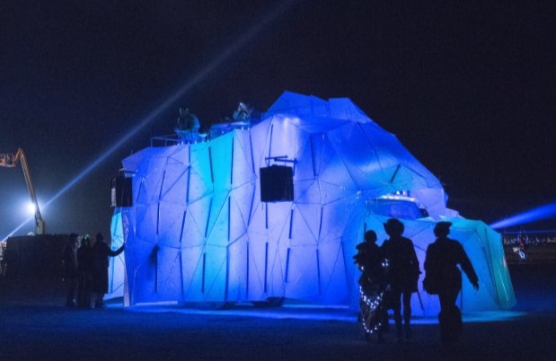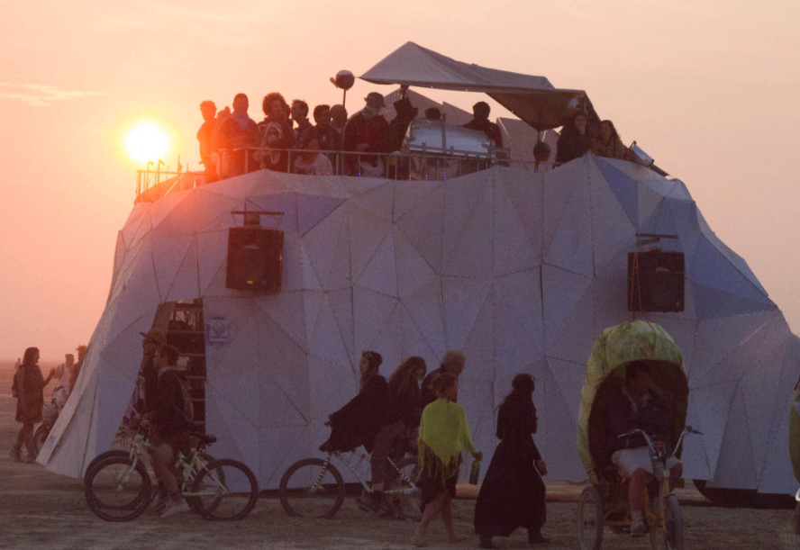

### We’re back

Targeting Burning Man, Titanic’s End 2022 is a significantly more ambitious project. The sound system will be comparable to the largest art cars created to date. While there will still be some backlit polycarbonate triangular panels, we’ll also be adding bright edge lighting to create a [synthwave](https://www.google.com/search?q=synthwave&sxsrf=AOaemvLDGLOtsTkyXkIsHG3HRanJdApPvA:1636091838310&source=lnms&tbm=isch&sa=X&ved=2ahUKEwiY_N2GxYD0AhV4l2oFHYO0AfQQ_AUoAXoECAEQAw&biw=1993&bih=996&dpr=0.9) feel. The idea of an iceberg in the desert invites thinking people to contemplate climate change.

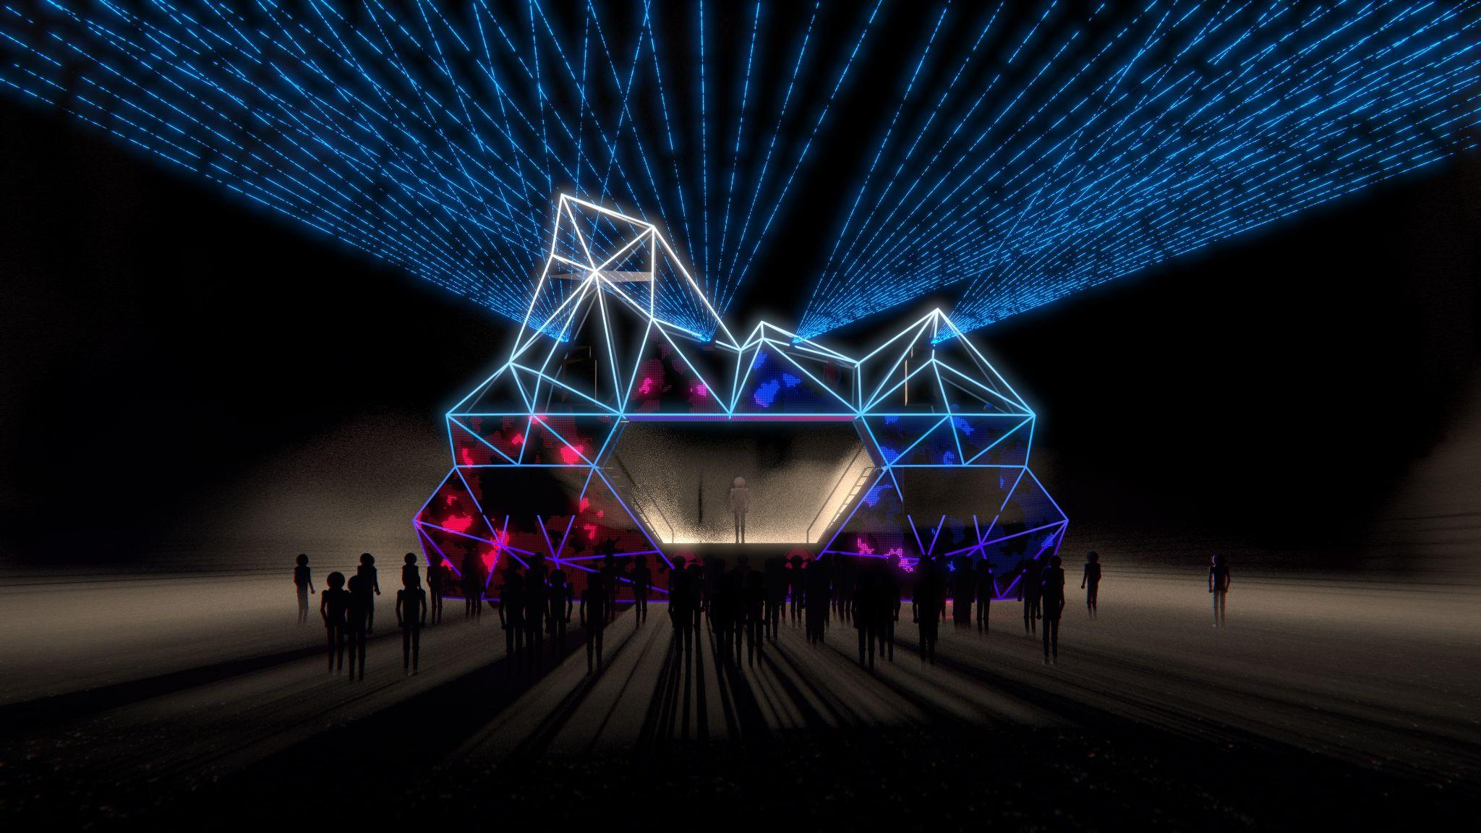

*Preview render as of November 2021*

Our team and this document are focused on bright LED lighting. We coordinate with teams that handle lasers, sound, projection mapping, ~~fog shots~~, hologram, and plan to tie it all together via OSC and ShowKontrol. The physical build of the steel tube structure is happening in Tennessee, and will be shipped to California for lighting and finishing in April.

We will likely settle in somewhere between 80,000 and 130,000 addressable LEDs. High frame rate (minimum 70FPS based on perceptual tests) is a requirement. We have a significant chunk of the 125KVA biodiesel generator’s power budget.

#### Current status and activities

As of May 2022, we have most aspects of the scope and design nailed down. We’ve selected our diffusion systems and about 95% of the materials have been ordered.

#### Lighting Components

In the rendering above, notice that some panels have red and blue fragments - these are the faces that will have backlit polycarbonate panels. All the polygon edges will have bright linear fixtures.

**Edges:** We’re lighting all 205 exterior edges on the car. We’ll be using 3 parallel rows (for redundancy and brightness) of 60/m SK9822 strips. The signal will be parallel as well, so one output point in LX is 3 pixels at the same distance into the three strips. We’re manufacturing a lens system with baffles to isolate and diffuse them. They will be the main thing people remember and associate with the vehicle. Aesthetically they are distinct, bright, and each window is sharply defined from the neighboring pixels on the edge. They’re mounted to the 2” tubular steel polygonal structure.

This all adds up to about 77K edge LEDs, composed of 26K addressable points in LX.

**Diffuse triangular panels**: The panels will contrast with the edges and be diffuse. After a 7-candidate prototype was built and evaluated by the team, we’ve chosen hig-transmission [Plastikote TUFFAK](https://plaskolite.com/catalog/tuffak-dx-nr) B48 white polycarbonate (.118” thick) as our diffuser surface. We’ve ordered ~40K custom [5V round SK9822 modules on a strand](https://www.aliexpress.com/item/4000908335640.html).

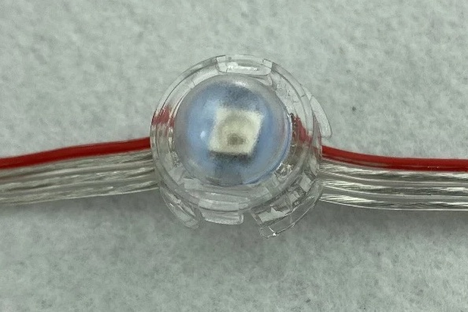

We originally wanted a lightbox that offsets them 2” from the diffusion surface. We observed an interesting semi-defined glow to each pixel at this distance; a middle-world of diffusion.

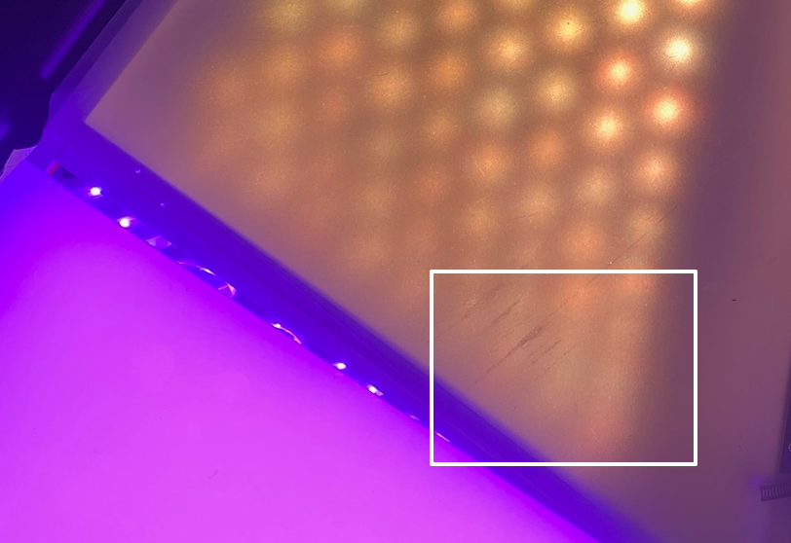

Due to manufacturing constraints, we instead will be sandwiching them right against the diffuser surface instead of at a 2” offset.



You can see the pixels will be mounted in a triangular grid pattern. This is visually interesting among the sea of square matrices out there and aligns with our overall triangular theme.

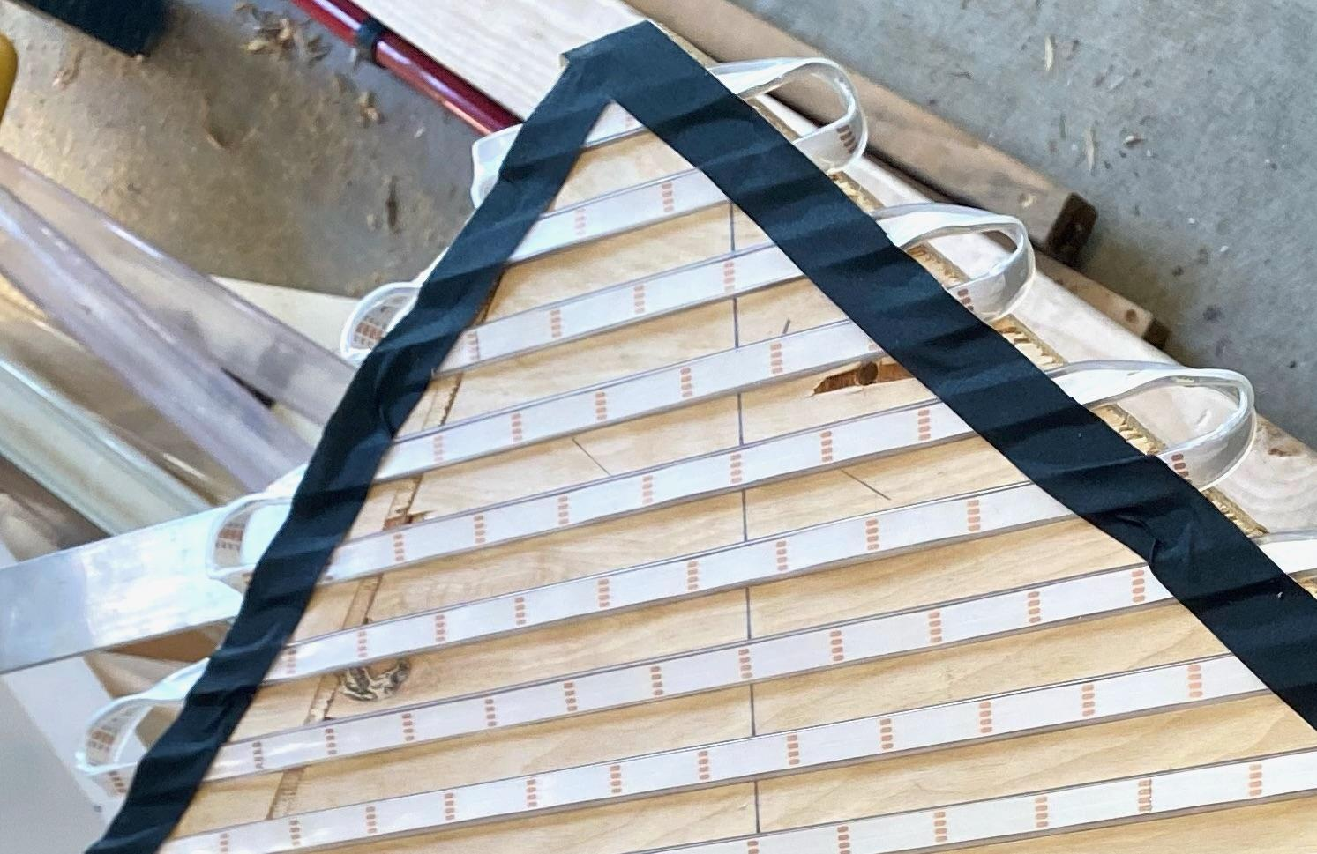

We initially thought we’d be going with a triangular grid made of 30/m IP67 [12V GS8208](https://forum.electromage.com/t/is-the-pixelblaze-v3-compatible-with-gs8208-led-strips/1310/3?u=jeff) strips, but even after several iterations of jigs and affixing techniques, we hated the additional labor of IP67 silicone strips.

In the first year, only the front and sides will have individually addressable panels. The back panels will likely be illuminated as solid colors or somehow edge-lit.

**Controllers:** We were planning to use the new Advatek Mk3 controllers for a sACN E1.31 based show. The launch release of the E16/A16 model was delayed from March to July, so we have commissioned custom 8-channel ArtNet controllers from Shlomo Zippel’s emerging company. See the spec [here](https://docs.google.com/document/d/1BWalTIG75oFIbEa10nq8PVxR_kefuTJ2w4g7DtKsBKk/edit).

**Software**: We’ve chosen LX Studio as our ‘pattern driver” or “workstation”. The maintainer, Mark Slee, has contributed to our project and is a true gift to all LED art. We can also use TouchDesigner and SMODE, should we want to include any artists who know those tools.

#### Resources

* We coordinate on Slack. [Join our workspace using this link and join #lighting-software and #lighting-hardware](https://join.slack.com/t/titanicsend/shared_invite/zt-12mwsg942-P2UzHpy~RW6EAus7~03OXQ).
* The lighting team meets weekly at 8PM on Mondays. There’s a calendar invite (ask anyone who’s on it to add you); zoom link(needs fix) and Notion agendas
* [Join our Notion workspace](https://www.notion.so/titanicsend/invite/6111b0e462e9727df082a7f95e2c07d78125d457). We maintain [a basic to-do board](https://www.notion.so/titanicsend/LED-Lighting-cb009503ac25426da1d93f1a65e8a35b) there - Browse through tasks with no owner and just pick shit up.
  + [Latest CAD revisions](https://www.notion.so/titanicsend/CAD-Files-last-updated-3-5-2022-df40417781784376ab16708e2986441a) for overall structure. See Packing ASEM.easm (use free eDrawing viewer) to understand how it is disassembled.
* The length, area, and dimensions of each “fixture” are in the [TE2 Modules, Panels, and Edges](https://docs.google.com/spreadsheets/d/1C7VPybckgH9bWGxwtgMN_Ij1T__c5qc-k7yIhG-592Y/edit#gid=1903823761) sheet. Start on the [Visual Map tab](https://docs.google.com/spreadsheets/d/1C7VPybckgH9bWGxwtgMN_Ij1T__c5qc-k7yIhG-592Y/edit#gid=877106241).
* The [Planning Spreadsheet](https://docs.google.com/spreadsheets/d/1Ao-e9cgfkJCsoVDn0W9LG18PeylfyRxDCiggUb9u3Z8/edit#gid=2091699403) helped us estimate how this will be 120-160K LEDs.
* We do more detailed estimation work and product sourcing in the [LED Products and Economics](https://docs.google.com/spreadsheets/d/1RXOtxLp2K_qTG547W8WxYTBKEPxlUkB8DTHj0yOSnJA/edit#gid=380329482) sheet.
* LED ArtNet → SPI [controller spec](https://docs.google.com/document/d/1BWalTIG75oFIbEa10nq8PVxR_kefuTJ2w4g7DtKsBKk/edit)
* Our code lives at <https://github.com/titanicsend/> (the main repo is [here](https://github.com/titanicsend/LXStudio-TE))

Many of us also hang out on the poorly-named but essential [LEDs Are Awesome](https://www.facebook.com/groups/LEDSAREAWESOME/) Facebook group, and Jeff is commonly on the weekly [Hackaday LED Chat](https://hackaday.io/messages/room/289684).

#### LX Studio (Controller software) Documents

The tutorials in the [LX Studio Wiki](https://github.com/heronarts/LXStudio/wiki) are an effective introduction

These have been compiled by our team:

* [Operation Modes and Art Direction Standards](https://docs.google.com/document/d/16FGnQ8jopCGwQ0qZizqILt3KYiLo0LPYkDYtnYzY7gI/edit)
* [Using Tempo and Sound](https://docs.google.com/document/d/17iICAfbhCzPL77KbmFDL4-lN0zgBb1k6wdWnoBSPDjk/edit)
* [APC40 and LX Studio](https://docs.google.com/document/d/110qgYR_4wtE0gN8K3QZdqU75Xq0W115qe7J6mcgm1So/edit)
* [LX Studio and Clips](https://docs.google.com/document/d/1jX5X-K8Pwxxg1NCt-gBaz8B_nKKTnzM_-RtkYA1dSH0/edit)
* [Auto VJ design document](https://www.notion.so/titanicsend/VJing-Protocols-34a400ffb1e34f5aaee595c22f140f5a)

As you really get rolling, you’ll appreciate the [API docs](https://lx.studio/api/) and public portion of the [source](https://github.com/heronarts/LX/tree/master/src/main/java/heronarts/lx)

Travis made a helpful [intro to LX Studio video](https://www.youtube.com/watch?v=82D7kNS3cog).

#### Team

If you’re interested in helping out, introduce yourself here. We can use help sourcing products, project management, physical build in SF, Sea Ranch, or playa; developing patterns and VJing.

[**Jeff Vyduna**](https://jeffvyduna.com/)- Lighting lead. Helped in 2014 but didn’t design it. Huge fan of Pixelblaze. A rusty electrical engineer and reluctant project manager.

[**Mike Schiraldi**](https://twitter.com/mikeschiraldi) - Software lead. Has designed LED projects for our camp such as our beloved geodesic dome lighting. Software engineer.

[**Alex**](https://www.linkedin.com/in/alexmtoombs/) **-** Low voltage power co-lead. Super lapsed electrical engineer who tinkers with lights and controls with Mike and the rest of Bao. (Also epileptic, which is always fun at burning man!)

[**Tom**](https://www.linkedin.com/in/tomwcahill/) - Low voltage power co-lead.

[**Aaron Haldinam and Sara Corbett**](https://www.instagram.com/creatingas1/?hl=en) **-** Design and fabrication for our linear edge fixtures

[**Keegan Olton**](http://www.keeganolton.com/) - Fabrication, physical design and sourcing expert

[**Mike Yoffa**](https://www.linkedin.com/in/yoffa/) - LX and ShaderToy pattern writer

[**Will Drevo**](https://www.linkedin.com/in/willdrevo/) - LX pattern writer, DJ, ML

[**Daniel Hull**](https://www.linkedin.com/in/daniel-hull-60582b18/)and[**Even Arteaga**](https://www.linkedin.com/in/evanarteaga/?original_referer=https%3A%2F%2Fwww%2Egoogle%2Ecom%2F&originalSubdomain=pr) - For us - Invaluable CAD support

[**Ali Momeni**](https://alimomeni.net/project-type/see/) - Leads the Media System group which is our on-car network. Projection mapping and interaction art.

[**Anthony Garcia**](https://www.linkedin.com/in/nicelasersanthony/), [Nicelasers](https://www.tiktok.com/@nicelasers?lang=en) - Professional laser designer. Laserface, Kanye, etc

[**Shlomo Zippel**](https://nocturne-x.com/) - is creating our custom LED controllers

[**Scott O’Hair**](https://www.linkedin.com/in/scottohair/) - Back side panel lighting

**Cesar Toscano** - Working on patterns and gesture controls as an input for pattern parameters

**Benny** - General home lighting tinkerer with zigby. Connecting Hue/Nano/off brand strips/Light DJ. Prior digital forensic investigator, now product manager for data engineering. Capable of some scripting.

**How to get involved** (software / pattern development)

[Stale] If you can write some Java, we have [a list of software tasks in Notion](https://www.notion.so/titanicsend/d4a7f54ab5f84784b79268e81c9342a7?v=1950f7f8703d498cb51e6e01ec84c577) that need your help.

We maintain decent READMEs in our repos at <https://github.com/titanicsend/>.

## The Design Process

### Big Decisions

These drive many other system architecture decisions. We’re mostly past these and have settled on a direction.

* Will we light the edges of facets (triangles/polygons), isolated faces of facets, edge-lit facets, diffuse across facets (like Titanic’s End 1) or combinations of these? For edges of faces: Points or diffuse or lightbox in between?
  + We have narrowed in on bright, direct edges for a synthwave vibe (perhaps 3-row SK9822 at 60/m); some of the triangular polycarbonate panels will be diffuse backlit ~~(perhaps WS2815 or GS8208)~~ - settled on round module strands due to ease of install and service.
* Time available from volunteer builders vs some modular contract manufacturing (which we’ve learned is a component of many large scale LED projects at Burning Man)
* Is it just the panels/surface, or should we be considering adding beam effects (e.g. lasers or narrow spots like [BAAHS eyes](https://www.facebook.com/BAAAHS.13/photos/a.518340824874464/3423415701033614))?
  + We’ve been fortunate to add Anthony Garcia, the main person behind the magic that is Laserface/[Nicelasers](https://www.instagram.com/nicelasers/?hl=en), to the team. He’ll be programming KVANT Spectrum 33s and Clubmax audience scanners.

### Mood board

* Mixed lighting types. It creates nice depth and uses negative space for contrast. The top of the car could be a wireframe version of the iceberg peak/ pinnacle. Then LEDs light the frame like one of these:  
  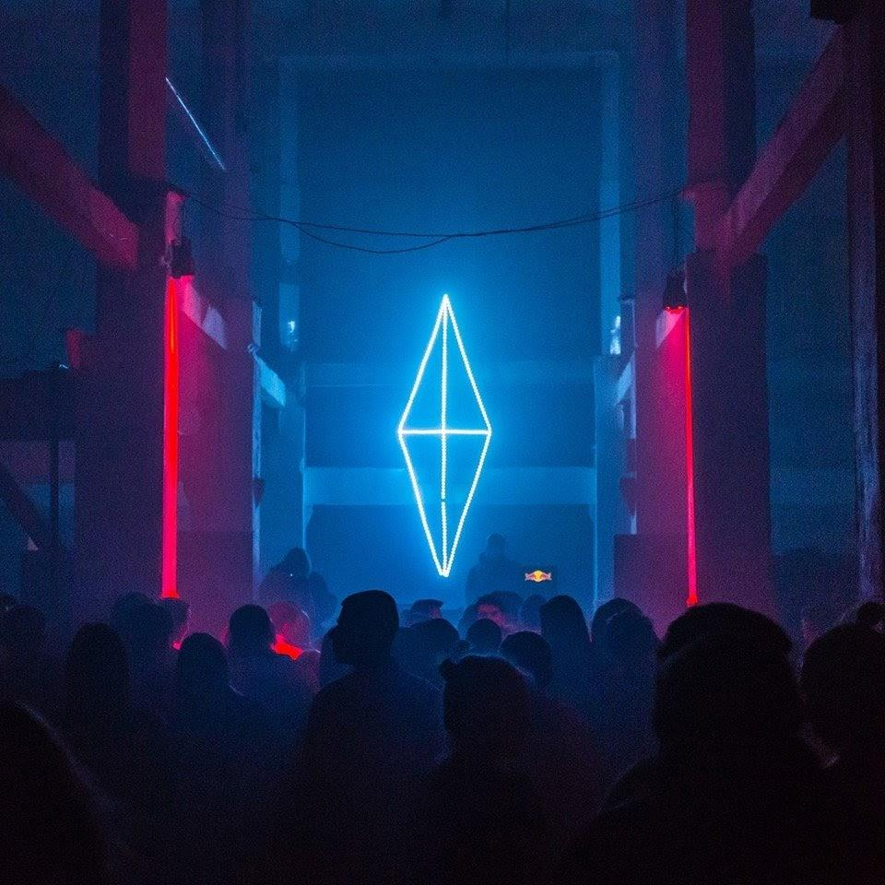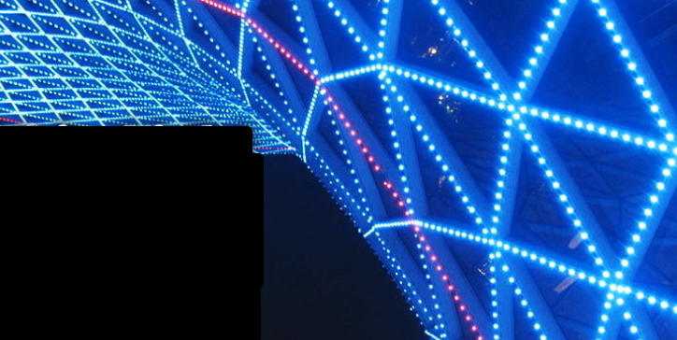
* The framed top would look iconic.

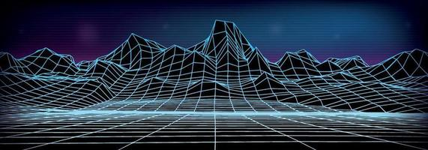

It would look as if we cropped just one of these peaks and put it on the top as the tip of the iceberg.

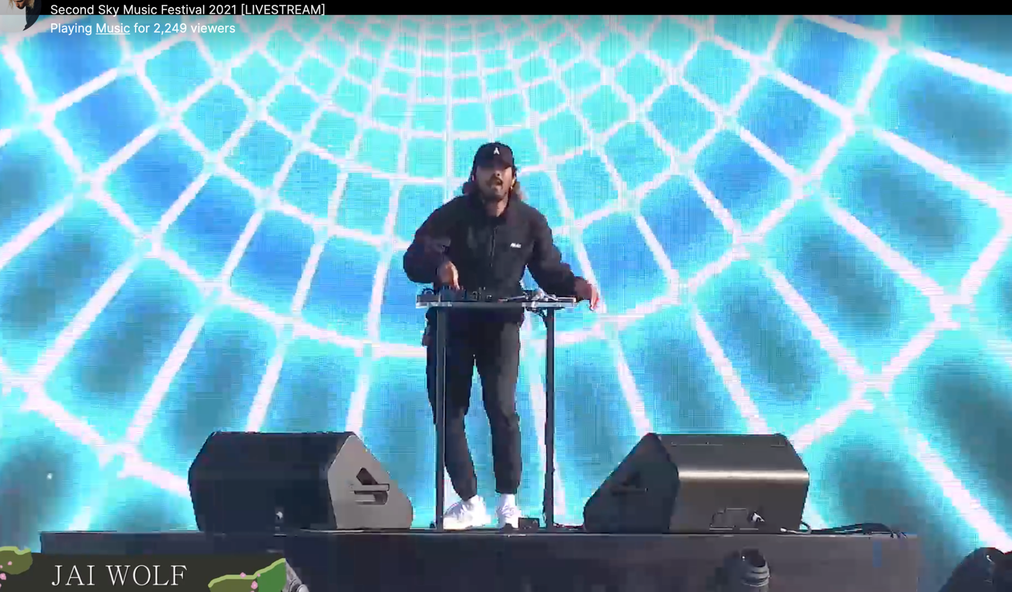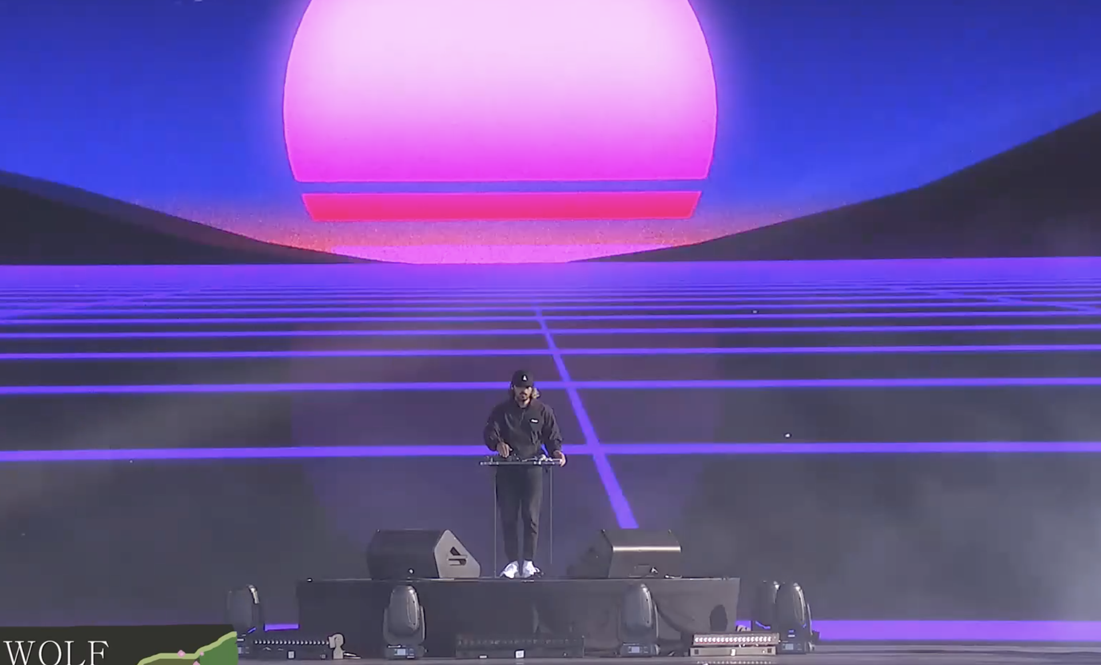

### Prototype for Diffusion Test

We built an 8’-per-side tetrahedral light box prototype in February at Humanmade in SF that [tested 7 candidate diffusion systems](https://docs.google.com/spreadsheets/d/1RXOtxLp2K_qTG547W8WxYTBKEPxlUkB8DTHj0yOSnJA/edit#gid=64051392) and hardware detail techniques. [Here are the dimensions](https://docs.google.com/spreadsheets/d/1xg3VyxFnoMtjiKc9JUttWGl9H9YlJPBahsxc7eyymcE/edit#gid=0). It incorporates the hardest angles we need to design for.

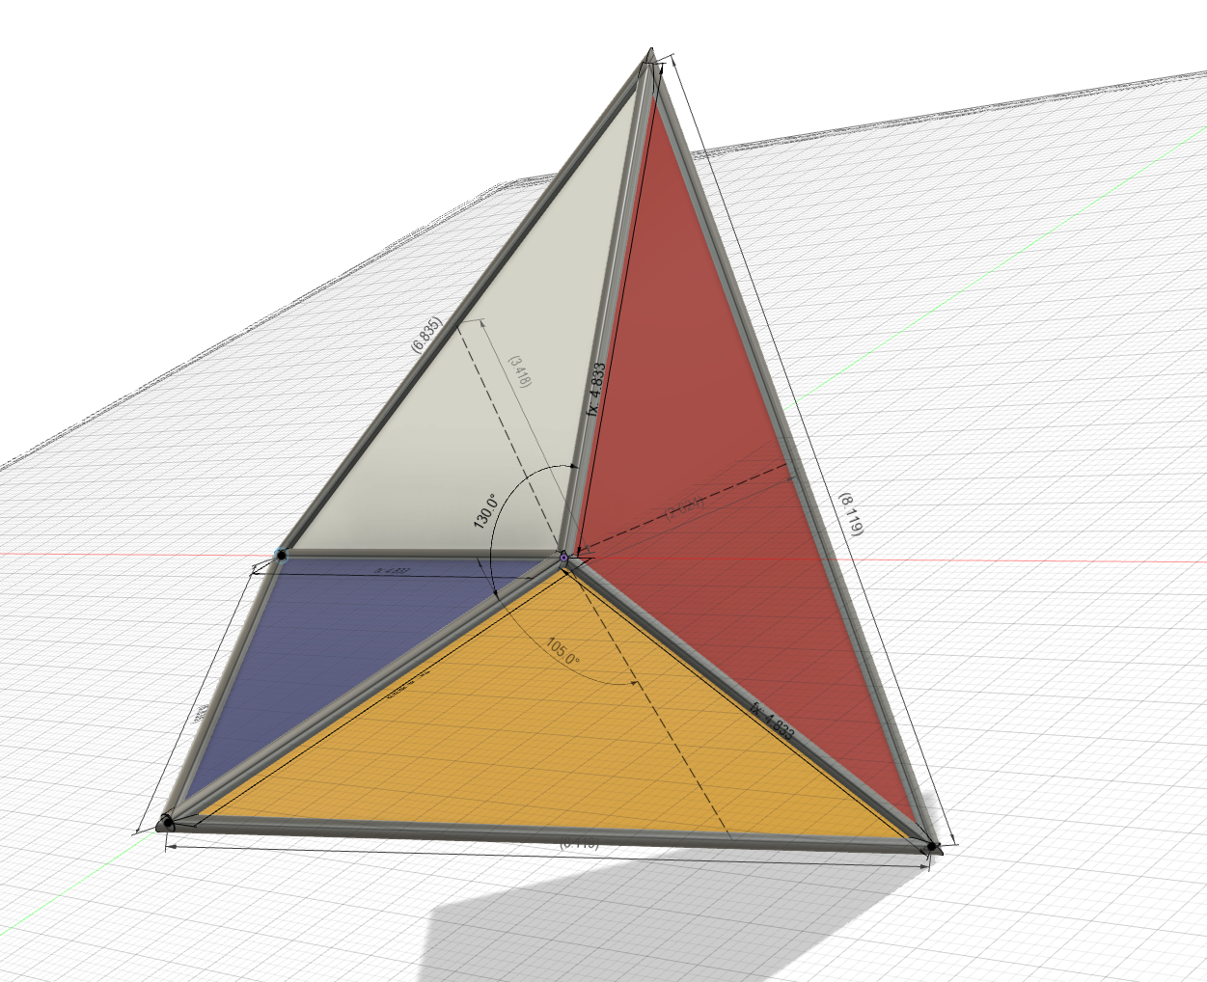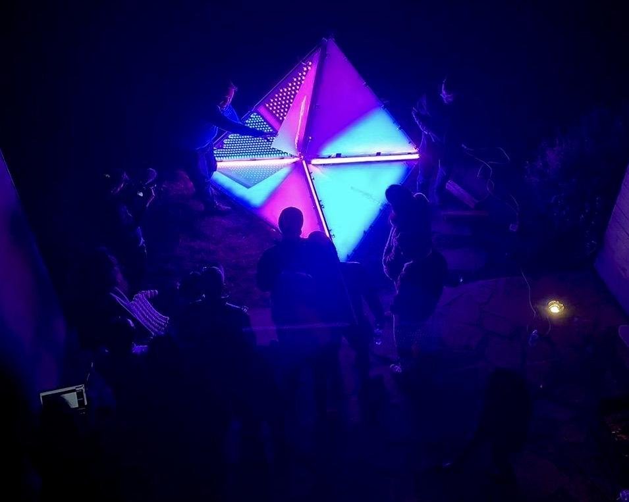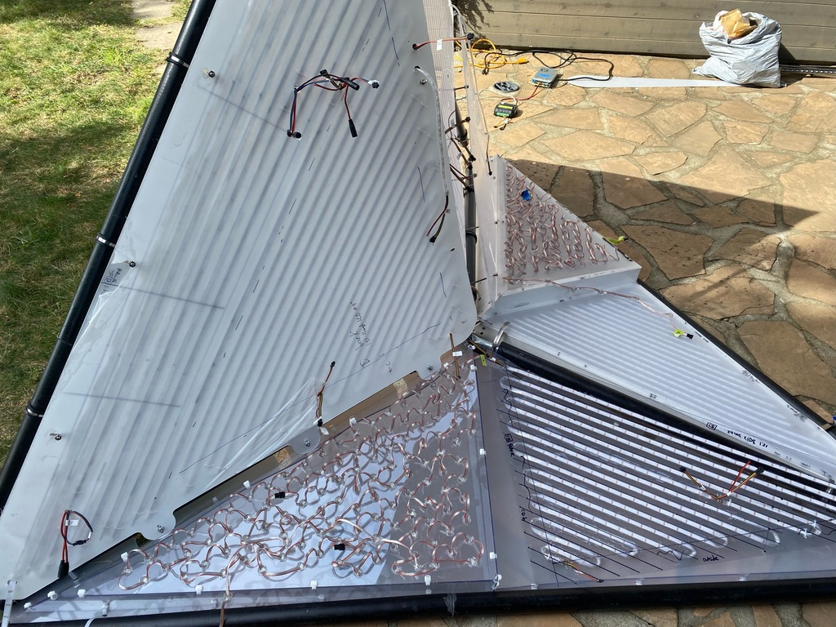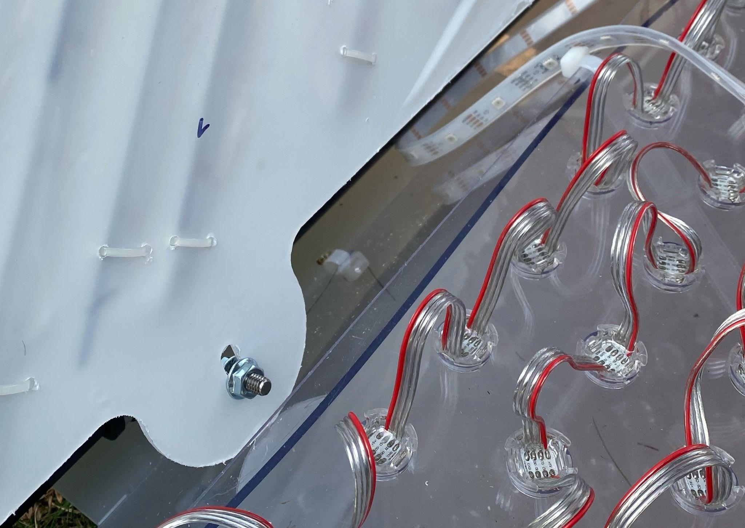

### 

### Reflections on Titanic’s End 1

Here’s a [great collection of pictures](https://www.kwonbae.com/works/titanicsend) of Titanic’s End 2014 (Thank’s David!)

We put the following questions to Justin and TE1 Lighting leads [Chris](https://www.facebook.com/chris.smoak) and [Tom](https://www.facebook.com/nottombrown) on what they’d do differently with architecture (anyone else we should interview?) A lot has evolved since then.

* I’m assuming since it was 2014 and Micah was at a build, that you guys chose Fadecandy with fcserver being controlled by Processing - is this right? Did LX Studio exist at the time? In retrospect, what did you like most and least about the toolchain and systems architecture? **Yes. See Chris’s answers via email below.**
* Could people with a little training VJ it via a UI?
  + **Justin: yes, this was super easy to do via a laptop with pre-set visualizations (Chris Smoak did this)**
* Were there any particularly failure-prone hardware situations?
  + **Justin: the LED connections broke all the time (we had soldered them ourselves and did not do a great job.). Also, transit was really rough on the connections and they often had to be repaired on playa. We should ideally get something with stronger connectors.**
* Any recollections on suppliers and yield?
* Do you have any historical code or docs you could share?
* How did you pick the diffusive material?
  + **Justin: David (Kwon) picked it - we didn’t do extensive testing with LEDs beforehand. Ideally we would want to get something that looks right (icebergy) but allows the most light through. I like the Huggzila look FWIW.**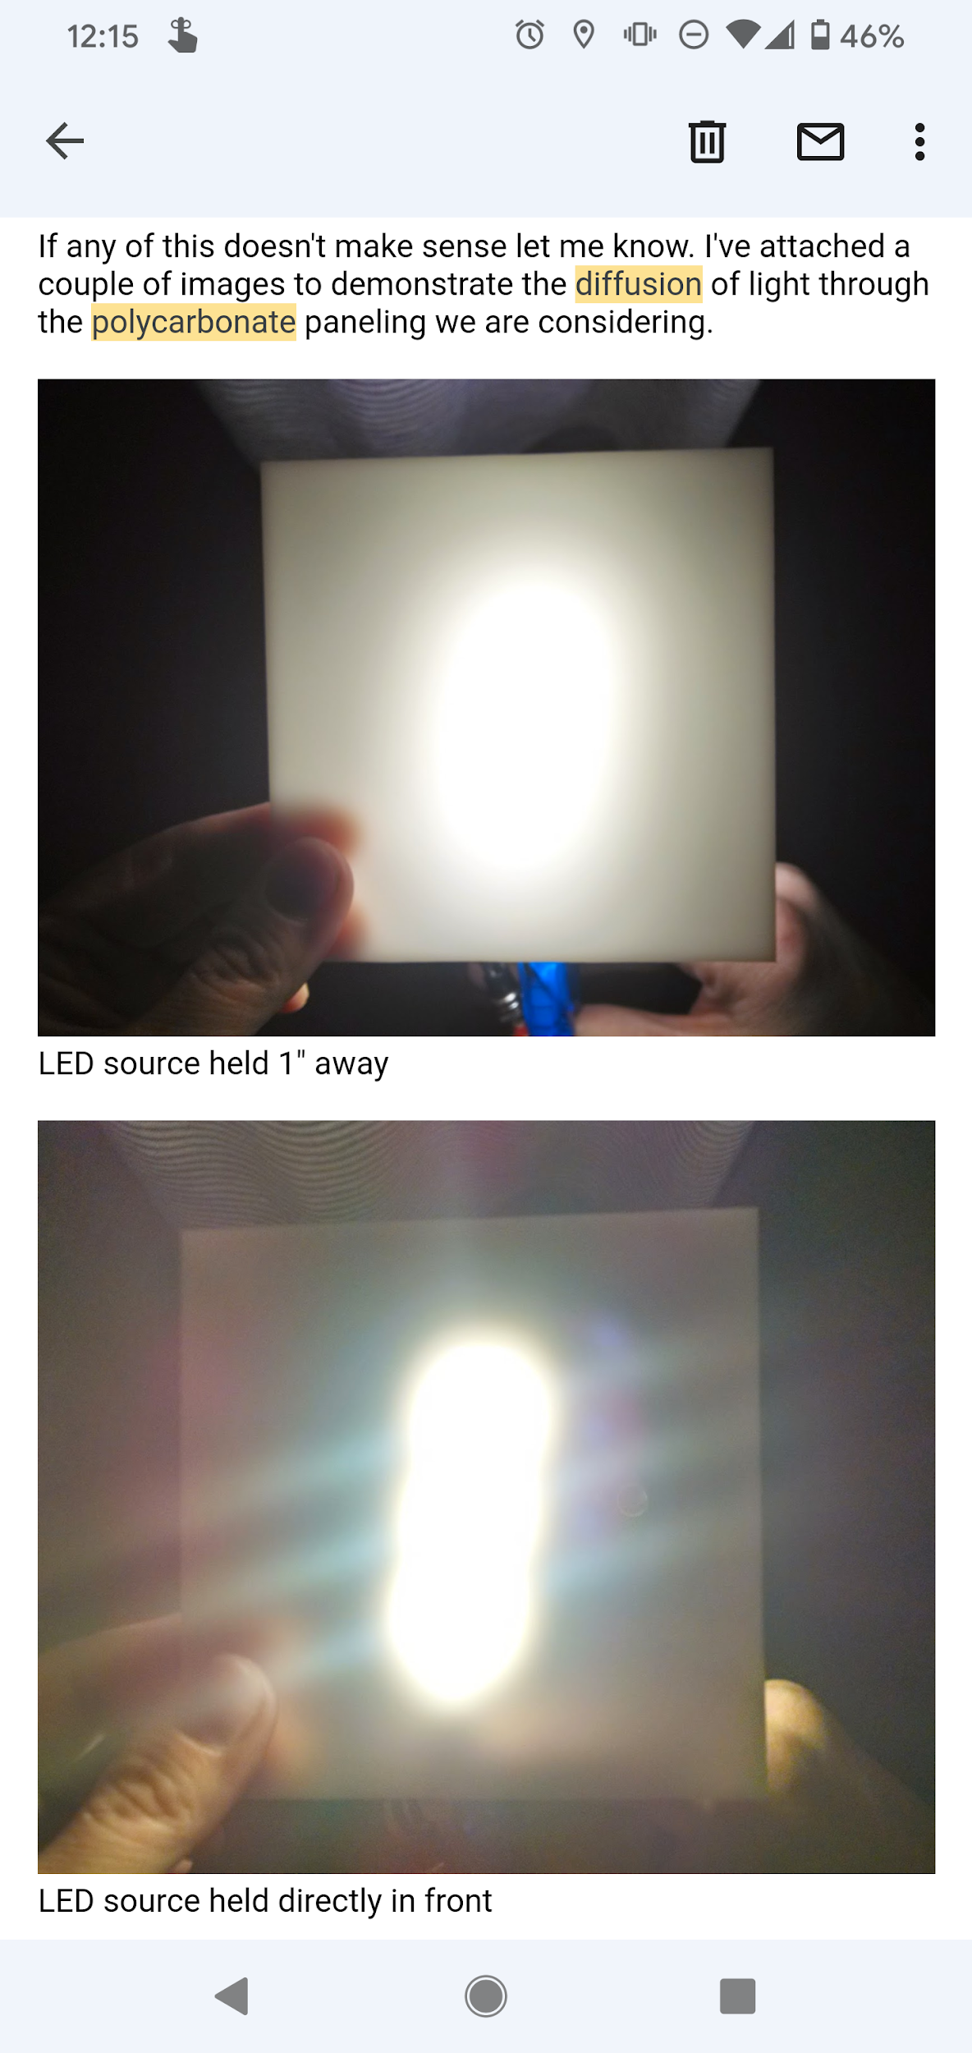
  + **David: Some preliminary mock ups from TEv1 below. Based on my previous research the spacing was about right (maybe it could have been closer), we just needed a shit ton more LEDs. If you want to read the diodes we go tighter, but if you want it to read more as an aura you pull back. Based on the scale of TEv2 maybe the diodes are directly behind the surface so it reads more like a large TV screen. That could create crisper graphics and make for more impressive visuals; would require a lot of LEDs though. Could research led panels and pixel density as a start to determine what resolution we want.**
* Were you able to do any sample testing / mockups / etc from home or did you really need to get it out there on the actual car to get a feel for how it would all work together?
  + **Justin: we didn't really know what it would look like until we put it all together. TBH it's amazing that it looked as good as it did. The major problems were durability during transit/construction, and brightness (due to diffusive material). We should have had like 5x the LEDs probably.**
* Did you reject any ideas that might be worth exploring this time?

Chris Smoak’s emailed answers:

Jeff,

Awesome! I did hear about the resurrection of TE in a new form and I'm excited to see what you guys create!

We did use fadecandies. I believe Tom did most of the hardware orders.

We used Processing (and fcserver, iirc) and an early version of LX that was a library at the time. The software toolchain was generally pretty good. Once we had fadecandies set up and knew their IDs, we created a 3d model of the LED layout that LX could use to let us run "patterns." Then it was a matter of coding up a bunch of patterns and making them reactive to music and giving them each a few params to tweak live. I have the code for this on an old laptop I can dig up when I'm next in SF. Maybe those patterns could give you a starting point for TE2.

Most patterns worked after simulating in Processing using LX. The main challenge was that TE's diffusing panels made details a lot harder to see than we expected and the resolution ended up being too low for all but the simplest shapes. We ended up with a barely-readable text scroller, a rotating cube, some dancing poses, and a kinda recognizable smiley face. Things that resembled old-school demoscene animations worked quite well. Fire, sound-reactive pulsating blobs, plasmas all looked great.

A different LED layout would have given us the ability to have more detail to the patterns. The LEDs were far enough from the panels (~1 foot) that they blended together quite a bit. They also ended up a bit dimmer because of the diffusion panels and were not very visible in the daytime. They were attached to the frame of the truck, so they were an uneven distance from the panels and diffused in different amounts across the side of the truck. They were in long strips vertically, so the vertical resolution was quite a bit higher than the horizontal resolution. The LEDs inside the truck were more in a more regular grid and closer to a (I think) foam diffusing panel. If I were starting fresh, I think I would create a simple 3D model in LX first to understand the target layout and gauge spacing beforehand.

There were ~7000 LEDs all-told. I think it was ~5000 outside and ~2000 inside. For the outside, we had strips of ~50 LEDs in a row, each strip powered by a fadecandy (I think each could address up to 8 rows of 64 "pixels"), all connected to USB hubs, which then were connected in a tree structure to more USB hubs ultimately to the limited number of USB ports on a laptop. We ended up using two laptops -- one to drive the outside and one to drive the inside lights. I think we mounted the outside LEDs to strips of aluminum, and we screwed these onto the frame. We used lots and lots of zip ties for cables strung across the frame. We had a few boxes mounted to the frame that would collect the cables and feed into USB hubs. I forget, but we may have also put power supplies in these boxes the second year.

One major challenge we never fully overcame was hooking up so many fadecandies through these USB trees to a single laptop. I assume there are better ways to do this by now. Our setup would randomly cause the laptop USB ports to turn off. We assumed this was because, even though there was a separate power source for each fadecandy and each USB hub was powered separately, there was enough power being drawn from the USB port that the laptop would turn it off. This would often also turn off the keyboard on the laptop, requiring a restart to get things working properly again. It also seemed random that not all fadecandies would register when plugged in, or some would disconnect and have a hard time reconnecting. I attribute this to the tree structure of the USB hubs, connecting so many to one place. We used a 17" macbook for one of the laptops and I think a 13" for the other. I don't think we had major issues with the laptops due to the playa, itself -- they got quite dusty but continued to function fine.

It was definitely a pain gluing all the LEDs together and connecting them to the fadecandies. This required a ton of soldering and things would often break. We assembled these strips beforehand and then did pretty consistent fixing on-site. If we had used premade strips it would have saved a bunch of pain.

For power, we had a plastic tub of power supplies with cables out to the fadecandies and USB hubs, a cable out to a power source (I believe we ran that to a generator on the back of TE), and computer fans out holes on the side to keep the power supplies cool. This sat in the cab of the truck where we also kept the two laptops that drove the fadecandies. I don't think we had major issues with the power tub, but maybe Tom remembers something. I believe we ran an audio cable from the DJ deck on top down to the cab that we could plug in to drive the sound-reactive patterns.

It was a bit hard to drive TE at night with the lights coming down to the top of the windshield on the top of the cab and lights below the windshield in front. If I did it again, I would block this light from the cab somehow to increase visibility for the driver.

Overall, it was a really fun project to put together, and I think it looked pretty great in the end. I'm happy to take a look at any plans you have for the lights or code for patterns and give my thoughts if that would be helpful.

Cheers,

- chris

Other build team recollections:

* Things breaking in transit
* Lots of zip ties and soldering power injection. Should we have more plugs rather than direct solder? It would make troubleshooting easier.  
  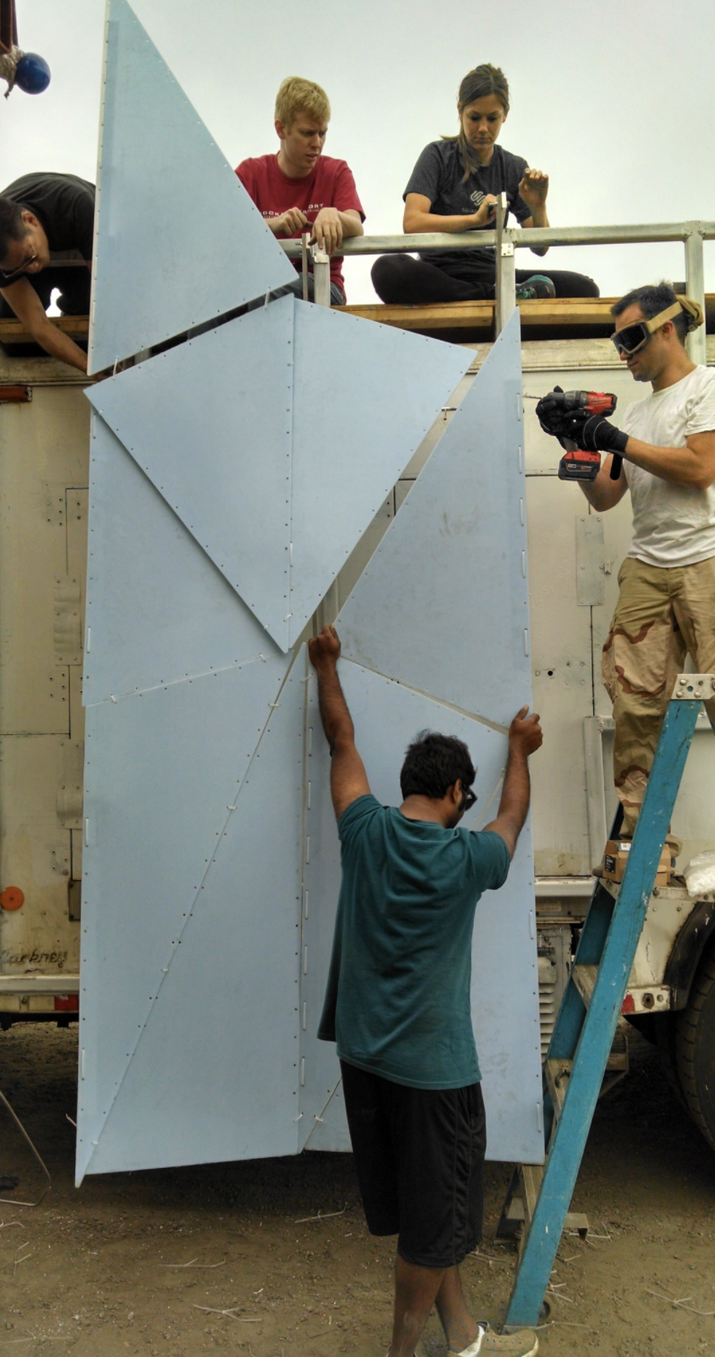
  + Idea: [Automatic Cable Tie Guns](https://youtu.be/eObc8SYGmmo?t=12) could speed cycle time a lot
* The overall form didn’t always clearly communicate “Iceberg” from a distance (year 2 added a pinnacle)
* Needs to be much brighter
* The polygon edges weren’t always easy to make out.
* The support structure back-shadowed the diffusive material (see vertical lines here)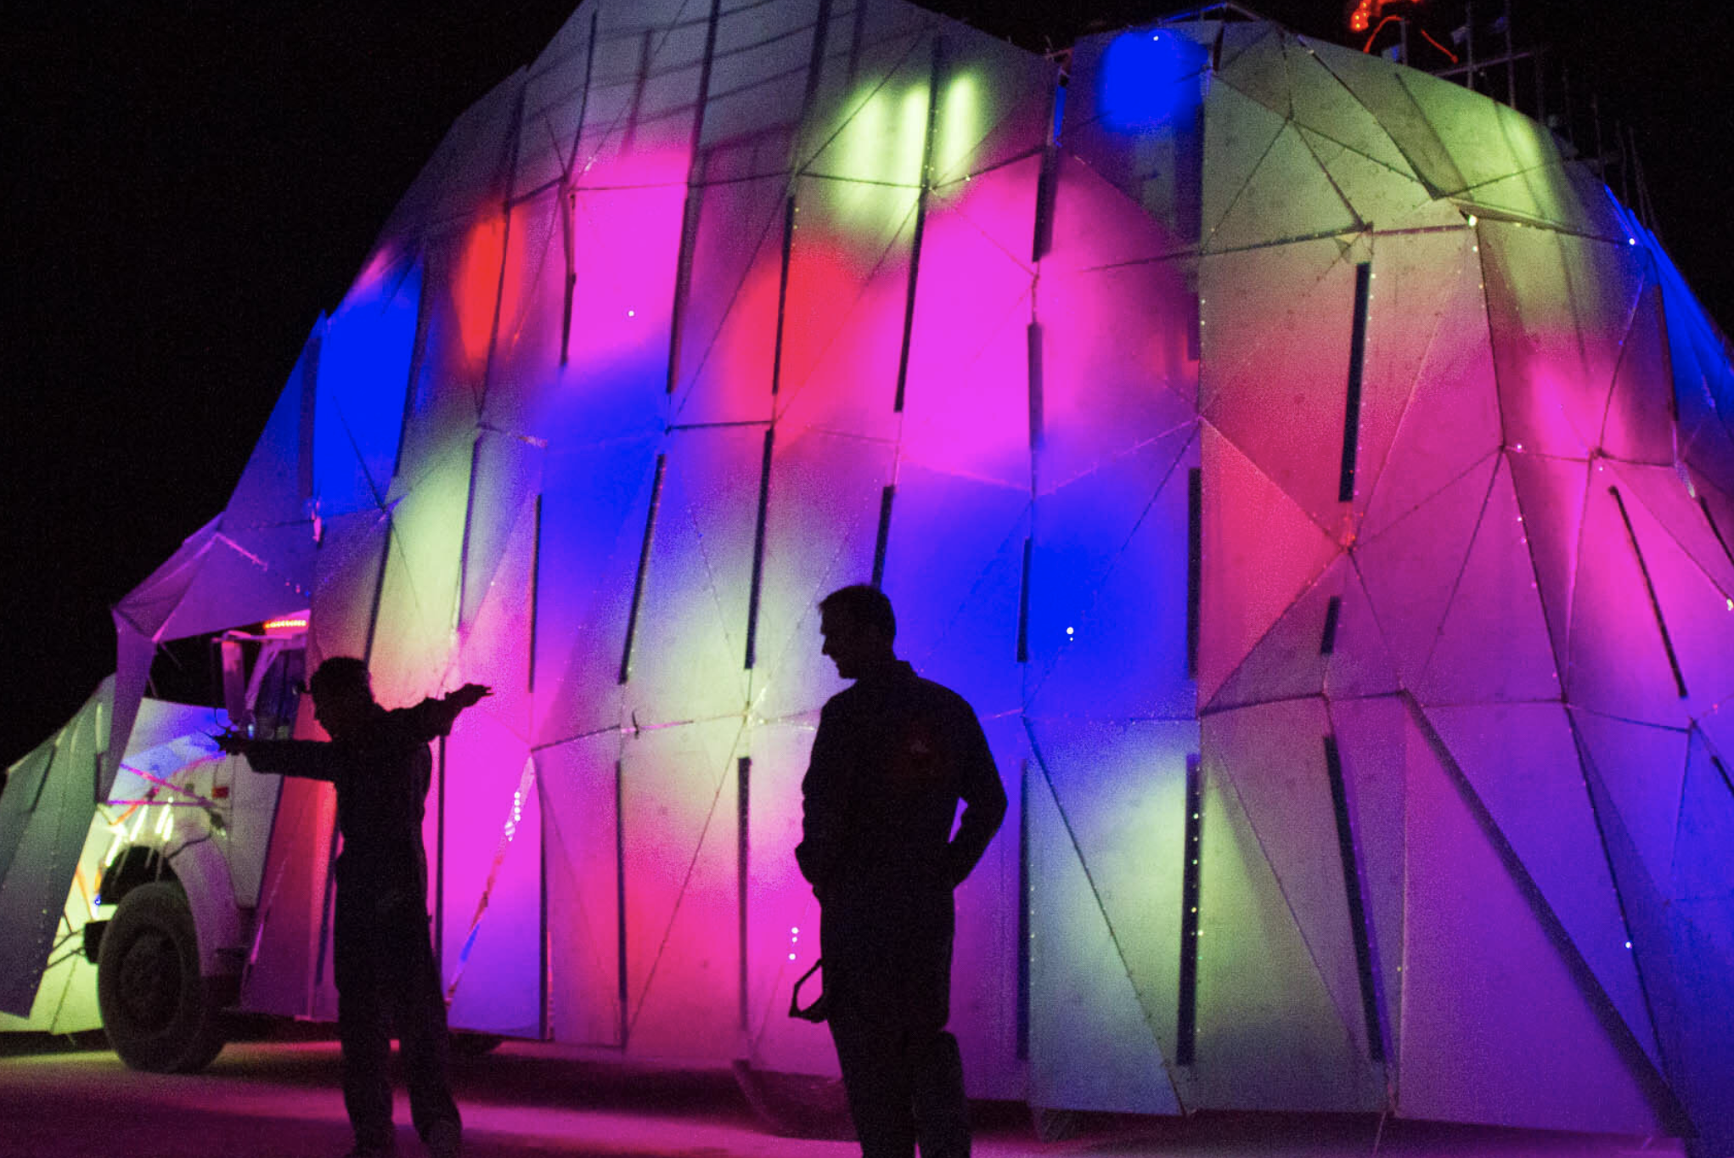
* Very high vertical resolution compared to horizontal (Pics show 30/m)

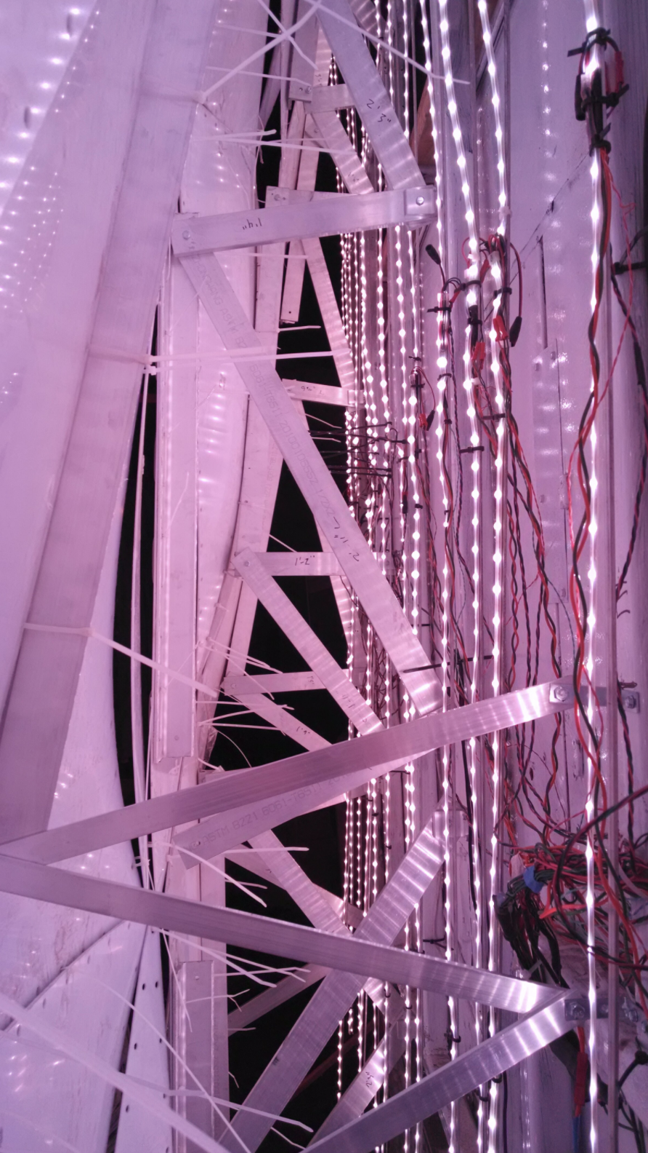

### Innovations in LEDs

What’s newish in LEDs or rare in art cars?

* HDR LEDs - SK9822 (AKA APA102 / Dotstar)
  + Faster, more beautiful, but 5V means more copper$ and injection/soldering
  + Lucy EsCarGo snail car chose these
  + There seems to be [some poor support](https://www.facebook.com/groups/LEDSAREAWESOME/posts/1684333815095404/) for using the 5 GBC (global brightness control) bits outside of Pixelblaze and LED Labs’ proprietary RaspPi player. Advatek is considering it. Mark Slee advocates for doing this as late in the chain as possible, IE a gamma curve in controllers but keeping 8bit/color data.
* [High density COB strips](https://www.youtube.com/watch?v=oaHNKGQZVis)
* [Side-firing LED strips](https://www.youtube.com/watch?v=HL3vxFtgS5s)
* 3D formable and right angle bendable [Zig-Zag strips](https://www.alibaba.com/product-detail/5050-zigzag-sk6812-ws2812b-5mm-5v_1600175966757.html) - strips that can wander the surface of a sphere. Not IP65/67/68.
* Flexible [Light Panels](https://nanoleaf.me/en-US/products/nanoleaf-canvas/)
* 12V (WS2815, WS2818) for less injection
  + The 12V strips/bullets are known for drawing lots of power even when not putting out much light. [12V->5V strips](https://www.advateklights.com/blaze-30-pixel-strip) are a recent innovation for this.
  + [GS8208](https://www.aliexpress.com/store/701799/search?origin=y&SearchText=gs8206) chip - built in 8->12 bit gamma. Jeff ordered a reel to check it out. [It’s impressive](https://youtu.be/2coFBuNDukQ) - we’ll use these.
  + WS2815 has been popular for its 12V support, but people report many reliability problems and bad pixels developing over time.
* Not that rare or novel now, but RGB addressable LED neon is still pretty, and there are many new diffusion form factors.

What’s nobody doing (to our knowledge) that’s technically possible?

* Using 2020 size LEDs as sparkles
* Using 16 bit per channel color: NewStar NS108 chipset driven by [SMODE](https://smode.fr/). There’s no off-the-shelf product as of Nov ‘21. A few controllers can speak 16 bit per color channel (note: Advatek confirmed over email their Mk3 will). We could design our own PCBs.
* Rare wavelength LEDs controlled by nice TI chips
  + We could really wow with mixing high-CRI white and rare blues/cyan
  + Custom manufactured runs of 5050 size chips are not too expensive
  + This is possible with current RGB products:



* + This deeper cyan / blue / indigo is possible with custom manufacturing:



Jeff ordered several 50W COBs of exotic wavelengths: Deep blue, Cyan 490 nm is particularly expensive (5X normal blue) for some reason.

* If Titanic’s End is polygons, why not write shaders? There’s so much great stuff already out there in GLSL. LX Studio will allow this paradigm.

Trends to be aware of:

* We want to be part of the movement away from using the entire thing as one big video “screen”; less of a regular matrix. We will pay careful attention to matching the patterns and content to the underlying concept and form.
* More careful palette use, less always-a-rainbow (see pics of other art cars above)
* Even working in a single color.
  + See many of [Leo Villareal’s portfolio](http://villareal.net/architectural) in B+W, including the Bay Bridge lights.
  + Jaguara is commonly purple; they might be using special LEDs in places that emit a dark purple that normal RGB LEDs do not
  + [Maxa Xaman](https://www.youtube.com/watch?v=EMKktxYzo74) (the deer) typically seen only in palettes, not rainbow
  + An example of really great lights that get lost on playa due to death-by-rainbow might be [Xuza](https://youtu.be/Eigjt-ryjkQ?t=73)
* Hide the LEDs - Side-emitting recessed in laser cut layers.
  + Skip a minute into the video of the [Meow Wolf Vegas build](https://www.facebook.com/groups/LEDSAREAWESOME/posts/1646503875545065/)
  + See [Sanctuary’s techniques](https://s.anctuary.com/gallery) and heavy use of silhouette
  + It’s probably harder to make a very bright car this way.

## Prior Artcars

### Lucy EsCarGo Is the snail people liked at Renegade Burn

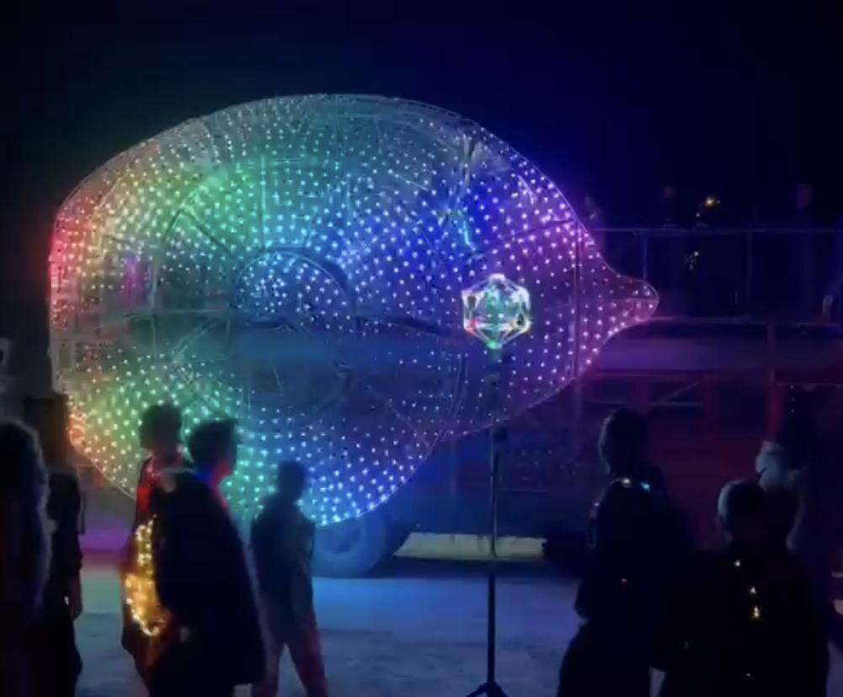

of Preservation Society (Hua knows [Piotr](https://www.facebook.com/piotr.brzezinski)?)

See components up close on [YouTube](https://www.youtube.com/watch?v=ZGttFrzADJg)

Christopher of Firmament/Paraluna did Lucy’s light design and most of [her magic is in the mapping](https://www.facebook.com/christopher.schardt/posts/10155666526826057) (though it’s only 2D).

### Mayan Warrior

Great attention to things at different scales

- what you notice from afar, as you approach, and up close.

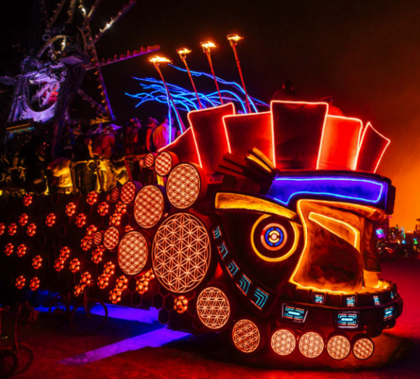

[70 kilowatts](https://mixmag.net/read/mayan-warrior-brings-its-illustrious-burning-man-art-car-to-los-angeles-news)

Light design for MW and Maxa by [Paolo](https://www.paolomontiel.com/)

Laser control by [Pangolin](https://www.paolomontiel.com/) using [Kvant Spectrum 33](https://lasershowprojector.com/products/kvant-spectrum-33-rgby)

### Sanctuary

[Project homepage](https://s.anctuary.com/?fbclid=IwAR2v04XlwonY6gpzTm5zPh3gmH840aNu5oHh1ihNbE4NCgFA4qAQyg8ZYmw)

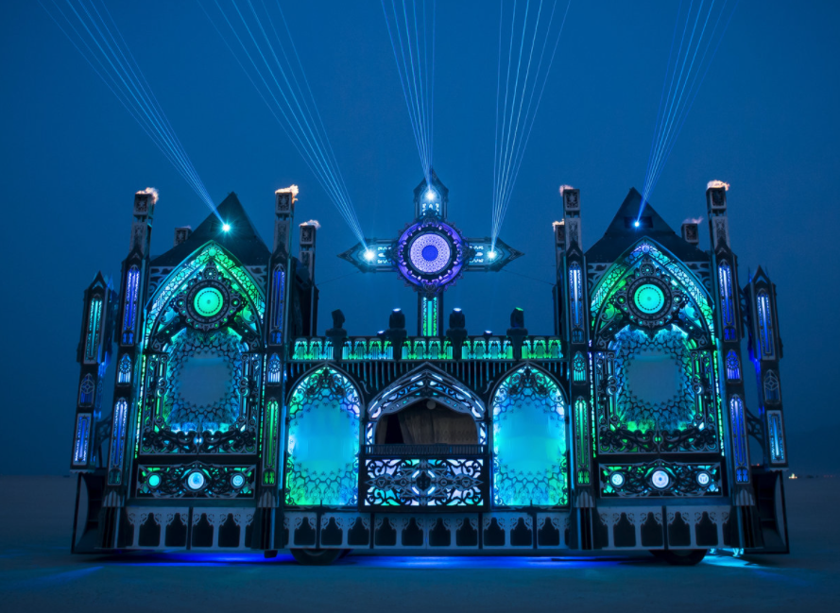

Show lead is Robb Pope of Digital Ambiance, who does the Luminous Arts podcast; Several other DA staff worked ed ed on Sanctuary. Sanctuary’s scenes are controlled by Madrix and they used PixLite mk2 controllers.

### Jaguara

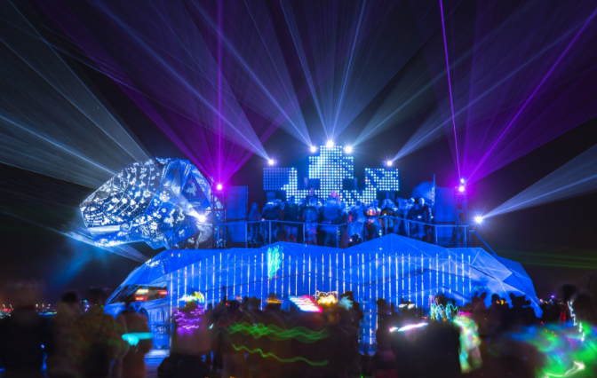

Body is vertical strips behind custom sacred geometry patterned metal panels (looks plasma cut).

Used very expensive [Elation Cuepix 16](https://www.elationlighting.com/cuepix-16ip) ($1000/16 LEDs) up top. This likely means the lighting was being controlled by nightclub-style DMX gear.  
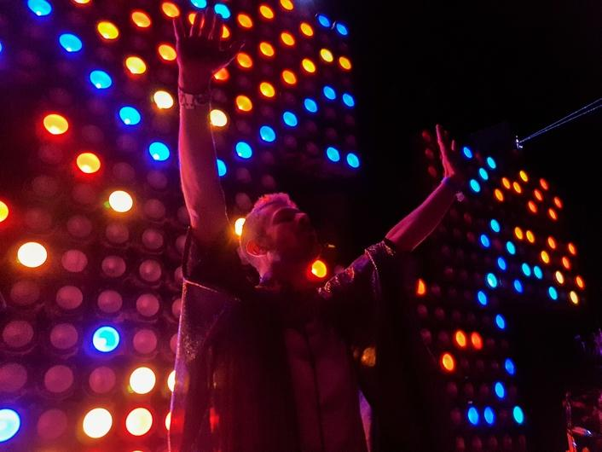

[Good video of lighting](https://www.youtube.com/watch?v=biEBI0VgtjA)

### (Not a car) Tree of Tenere

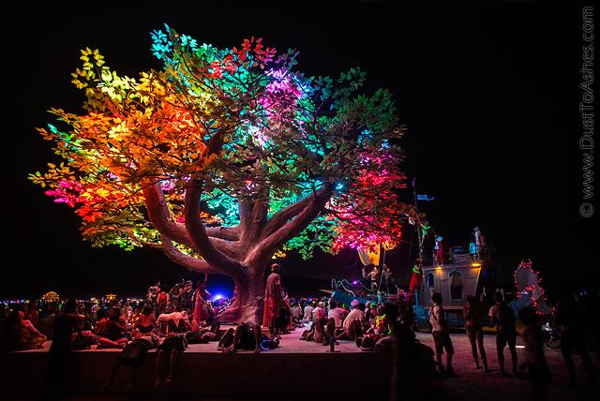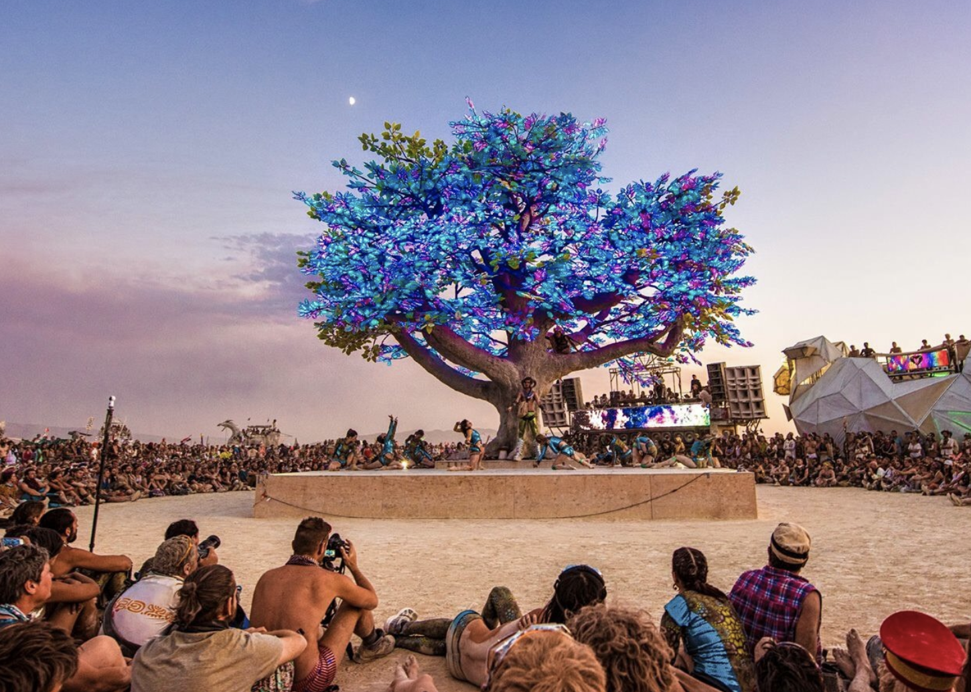

Very instructive information shared:

Podcast with creator / [lighting lead Mark Slee](https://podcasts.apple.com/us/podcast/mark-slee-luminous-podcast-episode-011/id1456693637?i=1000479649749)

Podcast [interview of project founder/lead Zach Smith](https://soundcloud.com/the-information-modest-conversations/25-making-of-the-tree-of-tenere-at-burning-man-zach-smith-founder-of-the-project) - great logistics tips

Used [LX Studio](http://lx.studio/) as the engine and 125,000 SK9822 over PoE

One collaborator was [Studio Drift](https://www.studiodrift.com/the-tree-of-tenere), who does the drone shows.

Magical: How the LED colors overpowered the green plastic leaves from within.

Used STM32 bluepills with an Ethernet chip. Booted with an arduino and running FASTled.

### Hugzilla

### *Project lead Ivan was kind enough to share tips in an interview.* *Notes below**.*

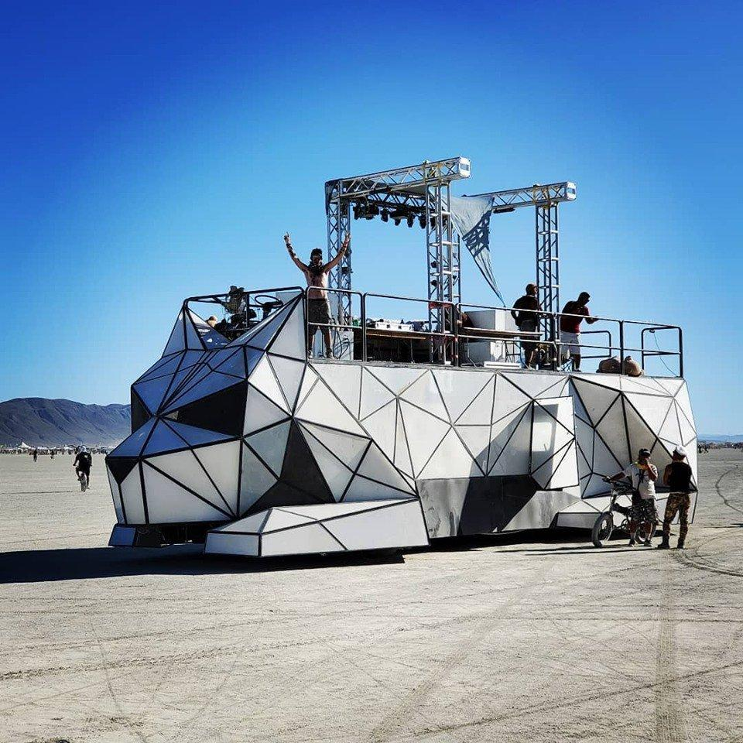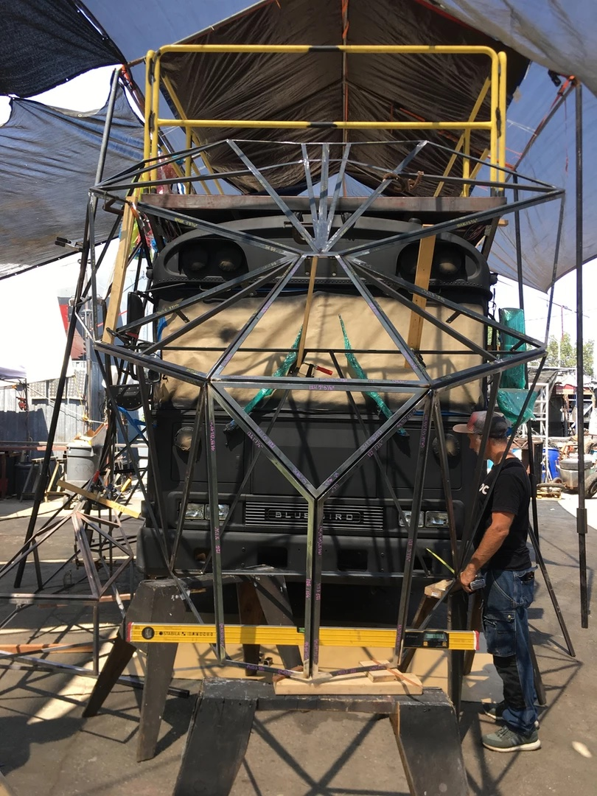

[Outsourced fab](https://www.stefanonovelli.com/); a few [structural assembly hints](https://www.instagram.com/stories/highlights/18034103113164468/)

50,000 LEDs. Can [render video like a screen](https://www.facebook.com/watch/?extid=SEO----&v=1096397197236953) (frame rate looked a little looked a little looked a little choppy - not enough controllers?) ([example 2](https://www.facebook.com/watch/?v=760543448025493)) as well as isolate the panels (see below). [See the interior](https://www.facebook.com/watch/?v=2549946741899391): Wow. 50K WS2811 bullets in a grid. Unless dynamic power limiting, that’d be 34kW (2900 amps) peak assuming 12V; perhaps 50% of that on average. Coming from 120VAC that’d be over 100 of the workhorse Meanwell LRS-350-12 power supplies ($3K). This is why it’s bright. The software looks like Madrix.

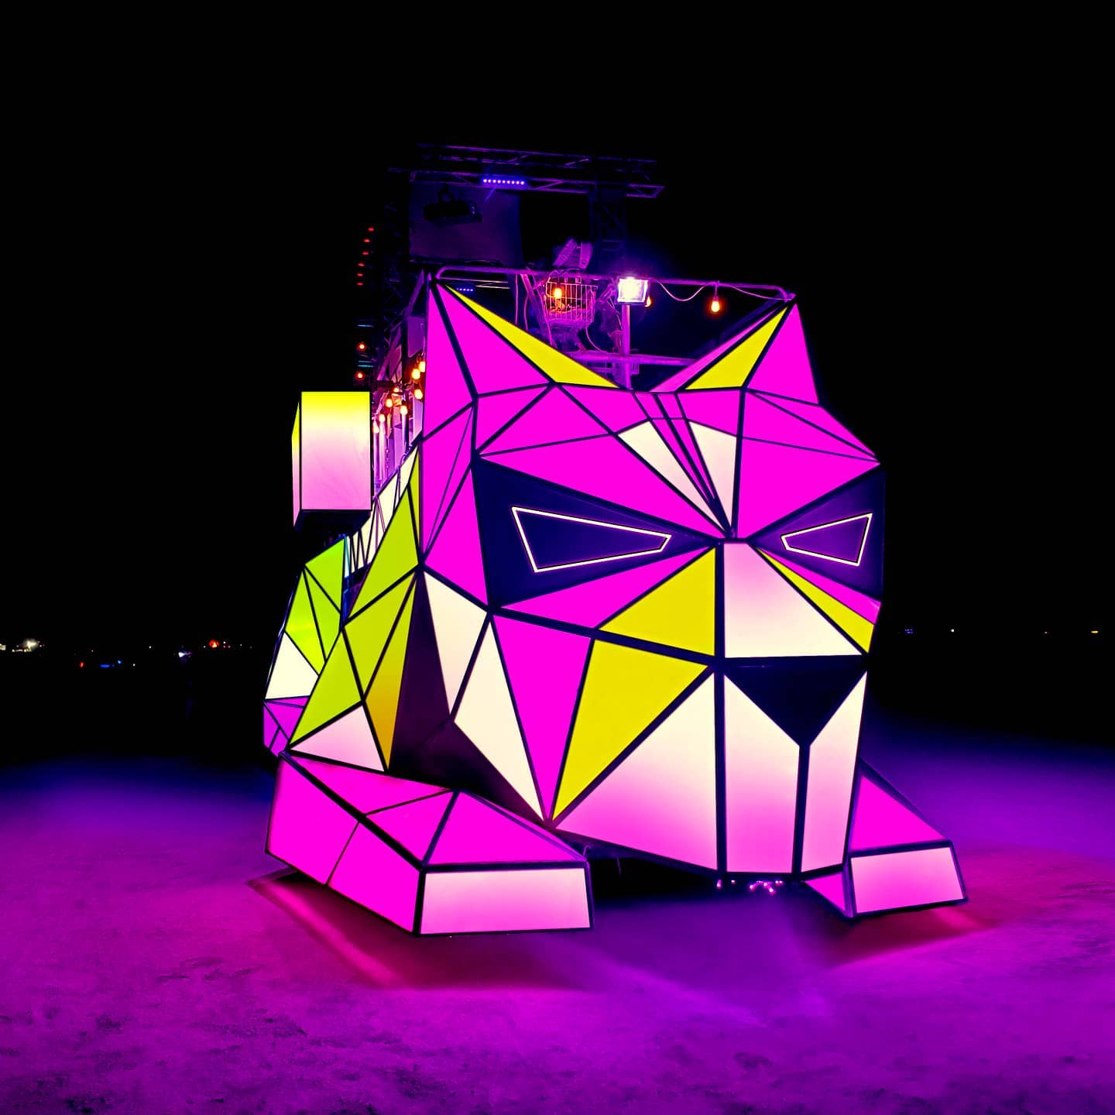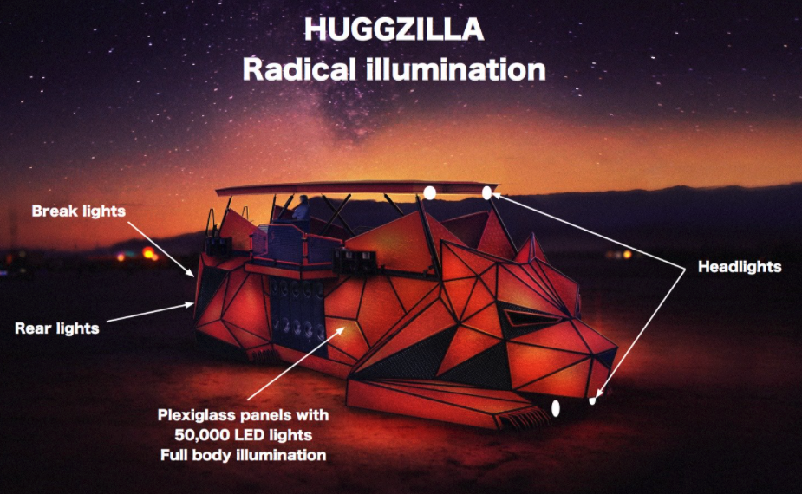

### BAAHS

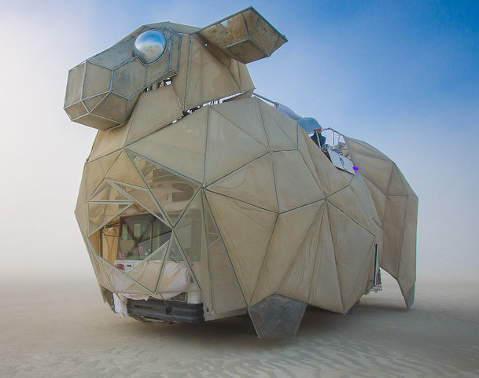

Fabric panels. They’ve upgraded the lighting since I first saw it in 2014. [Current lighting](https://www.youtube.com/watch?v=Qlpfjsgfq4w) looks reasonably panel-isolated, Has been diffuse lit from behind some years like TE1. It is now [mapped](https://www.facebook.com/518336291541584/videos/512384956341773), edge lit, and [has strips in curlys](https://www.facebook.com/BAAAHS.13/videos/442699886332488) within the panels.

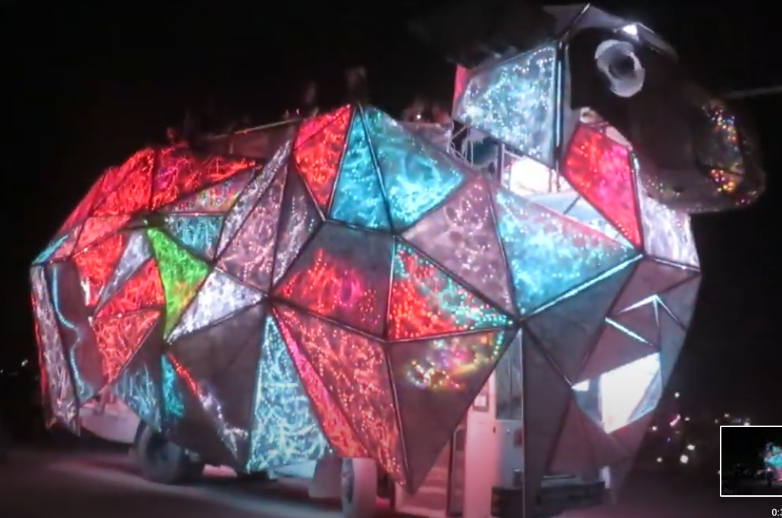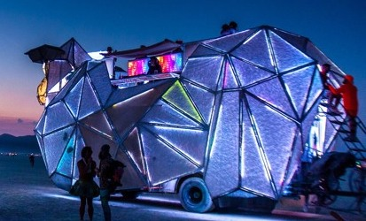

### Dragomi

<https://vimeo.com/443154751>

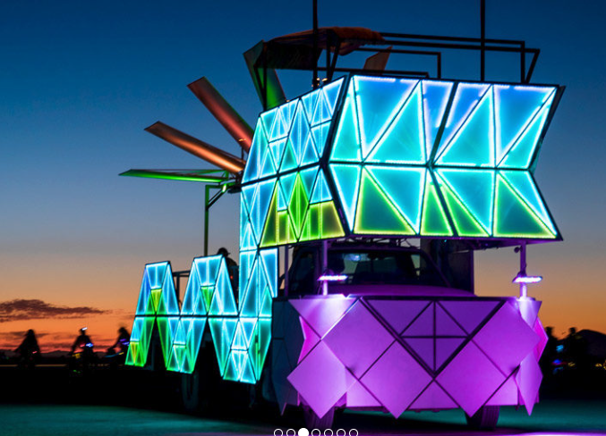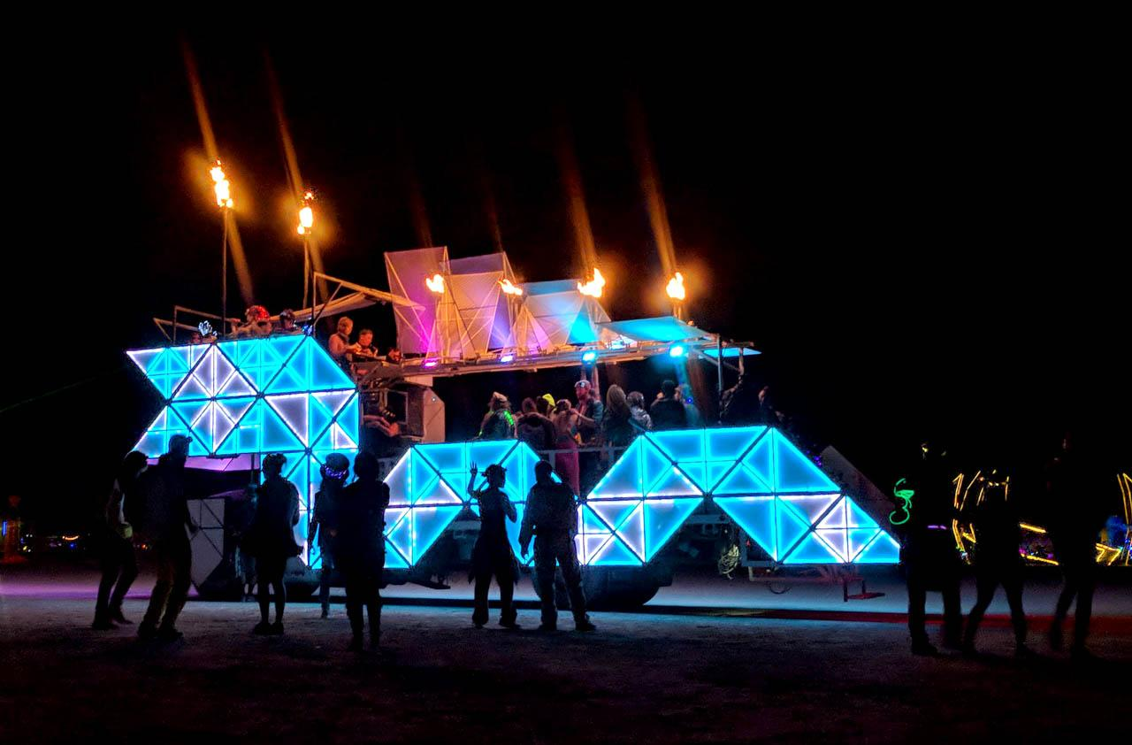

Light engine by founder/design lead [Hepp McCoy](https://www.linkedin.com/in/hepp-maccoy-789a3a1/) - Was at Symmetry Labs, which was a firm that forked LX Studio for Sugarcubes.

Funny - Year 2: “We added 7X the number of LEDs”

Year 4: “We added 30X the number of LEDs”

[Panels are edge-lit](https://dragomi.org/dragomi-2017-upgrades/): looks like 30/m to me.

Jeff emailed Hepp, the creator, for build lessons learned (they apparently had a rain problem one year). Super helpful tips below.

### Robot Heart

Basic RGB modules (strand/puck-type) zip tied to the underside (horizontal beams) and outside (diagonal and vertical of the L-channel.

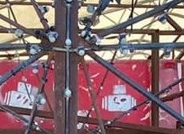

A similar but brighter effect could be done with 7-LED 50mm GS2806 pucks.

## Systems Architecture and Product Research

### Background

The [Addressable LED Controllers](https://docs.google.com/spreadsheets/d/10pHG7_VIVltyqJK1Y0T5g3Iq6YJV2MnhMp3UcAVB-GA/edit#gid=1749630164) community-maintained sheet is an invaluable resource. We’re using their terminology here.

At this scale, teams generally pick a *pattern driver* which pre-composes or live-renders a show. This runs on PCs or tablets. They send pixel data to *controllers*. Pixel data is commonly sent live over wired ethernet to the controllers. The three protocols seen most often are sACN (E1.31), ArtNet, or OPC. DDP is a high performance alternative with less controller support. Some art cars prefer to go headless, meaning they export a rendered show to SD cards that are put directly in one or more controllers to run with minimal interaction. Headless playback has reliability advantages but cannot be sound reactive. It’s interesting that a number of art cars seem to prefer headless in later years after initially going with live controllers.

A project can have one or more controllers. Controllers take their chunk of the overall pixel data and translate them onto one or more *channels*; each channel is a physical serial line of LEDs with the data rendered on strips or strands. Channels and controllers both scale with the total number of LEDs the project wants to use, and using more controllers can contribute to reliable, faster frame rates. Using multiple channels on a controller enables wiring in a star topology. Star topology is essential in most large projects in order to modularize. If the signal chain is broken, a team can replace smaller sections; in addition, many projects (especially using the unclocked and timing sensitive Neopixel protocol) find frustration with long signal runs. Best practice is to keep each channel to under 600 LEDs per run; 510 is common in Advatek.

The choice of pattern driver determines:

* Whether your overall show is sound-reactive
* Whether you can easily integrate commercial DMX fixtures (lasers, spots, floods)
* Whether you can do 2D or 3D pixel mapping
* Whether you can do generative art are or are just rendering mapped video
* Whether there are any VJ-like UI controls to control patterns
* The color depth/dimming you can work with. Much of the current state of LED art is limited by poor (linear) low-intensity dynamic range. To understand this, consider that your LED monitor can render lovely earth tones, but you’ve never seen earth-toned LED art on Playa - not that we want a brown iceberg, that’d look like… shit.

The choice of controller (sometimes confusingly called a pixel driver) determines:

* Available topology (number of channels)
* Pixel data protocols supported. Wired is greatly preferred over wireless by the experience in the community.
* Types of LEDs supported. The [Advatek site](https://www.advateklights.com/knowledge-base/pixel-leds) is a great reference.
  + Clocked pixels (WS2801 and APA102/SK9822) can run at 1-20MHz; unclocked WS28XX “neopixles” are signal limited to 800 Khz (33k RGB pixels/sec).
  + Color depth: 8 bit per color, 8 per color + 5 global, 8 but with 12 bit [gamma correction](https://youtu.be/2coFBuNDukQ), or 16 bit per color.
* Features like precise time sync across controllers, dynamic power limiting, and electronic fusing.

Commercial products tend to come from other industries such as advertising/signage, architectural lighting, holiday lighting, stage and theater, or nightclubs. To some degree all of these may limit creativity compared to what you might be familiar with from a strip connected directly to a microcontroller.

### Pattern Drivers

See [the sheet](https://docs.google.com/spreadsheets/d/10pHG7_VIVltyqJK1Y0T5g3Iq6YJV2MnhMp3UcAVB-GA/edit#gid=961824890) for the full list; this is the shortlist for us to decide between. The current favorites are ordered up top.

| **Product** | **The one standout** | **Pros** | **Cons** | **Projects that use** |
| --- | --- | --- | --- | --- |
| [LX Studio](https://lx.studio/portfolio) | Full creativity | Code (Java / Processing), generative freedom, sound reactivity. Mostly open source. | Code required for new patterns - then anyone can VJ on a UI  Documentation is thin | [Tree of Ténéré](http://lx.studio/tenere)  [Dr Bainlove](http://www.drbrainlove.org/)  [Mimsy](https://www.facebook.com/mimsyartcar/)  [Titanic’s End v1](https://www.kwonbae.com/works/titanicsend) |
| [Touch Designer](https://derivative.ca/) + [GeoPix](https://www.geopix.io/) | 3D show preview | Can do anything | Can’t find an art-car using this. “Connect pipes” interface. |  |
| [LED Lab](http://ledlabs.co/) | Out of the box wow-factor | iPad control (only)  Easy import of video | Not as expressive  Reports of bugs/[quirks](https://www.facebook.com/groups/LEDSAREAWESOME/posts/972010939661032/)  Can only get extra DR out of proprietary LEDPlay or Pixelpusher rendering chain, which is [end of life](https://www.facebook.com/groups/LEDSAREAWESOME/posts/1684333815095404/) | [Fluffy Cloud](https://www.thefluffycloud.org/)  [Lucy EsCarGo](https://www.google.com/search?q=Lucy+EsCarGot+%22art+car%22&tbm=isch&ved=2ahUKEwimwsHwtYbzAhUVB6wKHXbqBrAQ2-cCegQIABAA&oq=Lucy+EsCarGot+%22art+car%22&gs_lcp=CgNpbWcQA1DWFFigI2C9JWgAcAB4AIABdYgB4gGSAQMwLjKYAQCgAQGqAQtnd3Mtd2l6LWltZ8ABAQ&sclient=img&ei=RcFEYeaLBZWOsAX21JuACw&bih=1014&biw=2036)  [Prodigal Swan](https://photos.google.com/share/AF1QipM5UABfMBhSH5hhb1O9liGs5gcPGqHqXwsmuLXm6rAZAT0zDl3qmvcI_jmTiAiGQA?key=MFozY0htcUlPbjlGeFZmMDIwbDN5YmRFY1Y2cm5n) |
| [SMODE](https://smode.fr/) | Considered groundbreaking for 3D and generative art | Particle systems  Native 3D with live preview  No render cycle  16bit per color capable | Complex Expensive | No art cars found |
| [Madrix](https://www.madrix.com/) | Popular choice | Reliable, out-of-the-box | Windows  Annoying [price calc](https://www.madrix.com/support/calculator)  3D render preview?  Actually a 2.5D product | [Garage Mahal](https://www.hackster.io/philspitler/garage-mahal-art-car-758f6d)  [Sanctuary](https://s.anctuary.com/gallery)  Hugzilla |
| [xLights](https://xlights.org/) | Wide xmas user base |  | Partial OS X support  [Docs](https://nutcracker123.com/wk/index.php?title=Main_Page) look spotty / old | [Xuza](https://www.facebook.com/XUZA2.0/videos/2461314734167501)? |
| [Pixelblaze](https://www.bhencke.com/made-with-pixelblaze) | Wireless; HDR; simple; extremely fast dev cycle time (type, see render) | In-house experts  Active community | No sound-aware central control when using many thousands of LEDs.  No sACN/ArtNet |  |
| Madmapper and Resolume |  | Commonly used to do projection mapping | Actually 2.5D Not common tool of choice for our scale and aspirations ([1](http://forum.garagecube.com/viewtopic.php?t=33621)) |  |
| None - roll our own (e.g. FastLED endpoints, central control) |  |  | Reinventing too much  Extra work to author offline (pre-viz) |  |

### Controllers

Current favorites are ordered up top.

| **Product** | **Pros** | **Cons** | **Cost per 500 LEDs\*** | **Projects that use** |
| --- | --- | --- | --- | --- |
| Advatek [PixLite](https://www.advateklights.com/pixlite-16-mk2-control-board) | Popular, recommended  Reliable  [Mk3](https://www.advateklights.com/downloads/datasheets/pixlite-mk3-processor) is high frame rate  eFuses | No HDR for 8+5 bit LEDs (respects global brightness only) | Mk2: $16  Mk3: $62 | Sanctuary |
| [Falcon F16v4](https://www.pixelcontroller.com/store/controllers/70-f16v4.html) | Popular, recommended | Supply chain problem. Out of stock. | $11 | [Xuza](https://www.facebook.com/XUZA2.0/videos/2461314734167501) |
| LEDPlay (no product page, proprietary) | Supports HDR | Only works with LED Labs  Proprietary, side project of a busy artist, small user base |  | [Paraluna](https://www.youtube.com/watch?v=CIYvLsbYlSk)  This is Christopher Schardt’s proprietary RPi-based controller |
| [LeDMX 4 Pro](https://dmxking.com/led-pixel-control/ledmx4-pro) | Supports 24+5bit (no on-board gamma to 13) and 3x16bit HDR | No known art car users | $31 |  |
| [Pixelpusher](http://www.heroicrobotics.com/products/pixelpusher) | Supports HDR | [Is end of life](https://www.facebook.com/groups/LEDSAREAWESOME/posts/1684333815095404/)  Out of stock for a year. | $16 | [Foldhaus](https://www.foldhaus.com/radialumia) (Origami flowers 2014, origami mushrooms 2016, Radialumia 2018 “the virus”).  Lucy EsCarGo |
| [Fadecandy](https://www.adafruit.com/product/1689) | Strong community  Temporal dithering feature only in this and Advatek | [Is end-of-life](https://groups.google.com/g/fadecandy/c/PbXFbPHZWQI)  Requires FCServer on a RPi to get OPC data in; sACN/ArtNEt requires even more bridging ([OLA](https://www.openlighting.org/ola/))  Temporal dither technique limits the architecture to 64 pixels per channel  APA102 control is limited | $25 | Famous for [the ardent cloud](https://www.flickr.com/photos/uhlume/9716670276/) |

* Assuming 40+ FPS, IE <600 per channel for Neopixels

#### What is “Mapping”?

Mapping is a term that’s confusingly used in many different ways in the LED world.

* Remapping a light’s logical address to physical address (such as “this light is index 200 in this chain; however, use the data intended for index 199 instead”). The address to be remapped can yield a DMX universe + offset, fixture start address, channel number, or the index in the physical serial shift register of pixels. Mapping in this sense can decouple a physical installation from the source pattern material. You can reverse segments, enable more convenient wiring options, skip addresses, or mirror sections.
* Mapping in the pattern driver software usually refers to providing 3D coordinates for the physical location of each LED or lighting fixture. In this way, you can render source material such as 3D scalar fields through the lights. Planes of light through volumetric displays are using this kind of pixel / voxel mapping. [Example from Pixelblaze](https://youtu.be/Z19zAtSXPRw?t=41). Titanic’s End v1 did this via Processing/LX Studio.
* Projection mapping is similar, but grew from using projectors on 2.5D or 3D projection surfaces. You configure VJ software like Madmapper to understand the position and geometry of projection surfaces. You’ve seen this effect at shows. You’re mapping a Z coordinate onto each x/y pair of a projector’s output and then using 3D transforms or treating each surface as a separate object. This technique can add surreal life to surfaces.
* “Mapping” is sometimes used to refer to the math of functional transforms, for example “tone mapping” 8 bit-per-color source material through a gamma correction function or LUT to provide more than 8 bits of final dynamic range.

#### Code: Required, Optional, or None?

If code is required, the set of people who can understand, repair, and expand the patterns is greatly limited.

If code is an option, we will be able to realize more creative visions and create things never seen before. It becomes easier to create patterns that are specific to the form and essence of an iceberg.

Without code, we could:

1. Use the built-in patterns of any pattern driver, create playlists, and tweak parameters.
2. Use GUI pattern builders such as Madrix and LED Labs ([example](https://www.youtube.com/watch?v=i1vF1UqOrOo))
3. Create patterns by importing images and video files. These videos can come from After Effects and other generative tools, YouTube, GIFs, etc. Some of Firmament and Paraluna’s patterns are done this way. The downside is these are never truly music reactive.

### Power

Sound will be 115 or 230VAC; Lighting is currently planning on taking either from the generator. We’re looking at a large number of [Meanwell RSP, HLG, or or or UHG/LSP/LPV series](https://docs.google.com/spreadsheets/d/1RXOtxLp2K_qTG547W8WxYTBKEPxlUkB8DTHj0yOSnJA/edit#gid=1871067356) at 80-90% efficiency. We’ll probably choose RSP-320s.

In 5V, take the number of LEDs, multiply by .375, and that’s the watts of 120VAC needed for a system that’s safe in an accidental all-on-white condition. Note that while this may make it seem like the 5V LEDs use more power, they are generally considered brighter per LED and per watt due to how the 12V LEDs sink current inefficiently through the FETs due to how the 12V LEDs sink current inefficiently through the FETs due to how the 12V LEDs sink current inefficiently through the FETs.

In 12V LEDs, a rule of thumb could be to take the number of LEDs, multiply by .3, and that’s the watts of 120VAC needed for a system that’s safe in an accidental all-on-white condition.

We can save money on power supplies while still enjoying localized peak intensities if the controllers or pattern driver provide power management features like FastLED does.

The Advatek A4-S Mk3 includes 7A/channel electronically resettable fuses. This is proving to be of limited value in 5V systems. (7/60mA = 117 peak, 234 average LEDs per channel)

The [planning spreadsheet](https://docs.google.com/spreadsheets/d/1Ao-e9cgfkJCsoVDn0W9LG18PeylfyRxDCiggUb9u3Z8/edit#gid=2091699403) attempts to estimate how many 12V and 5V power supplies will be needed based on the most recent estimates of square and linear feet from the structural team.

#### Power Calculations

“Neopixel” is Adafruit branding for 5V or 12V chips that run at 33kPix/s max and have 8 bits per color, with poor low-intensity dynamic range. They use a single data line. These are commonly referred to by their WorldSemi model numbers such as WS2811, WS2812b, WS2813, WS2815 (12V), SK6812, etc.

“Dotstar” is Adafruit branding for 5V-only chips that run at 940kPix/s max (short runs) and have 5 additional bits for current-regulated brightness control across all three RGB LEDs in a chip, enabling a very noticeable HDR increase in color depth and wow factor. They use separate clock and data lines to achieve the large increase in throughput. They’re commonly referred to by their Epistar/APA/NewStar model numbers such as APA102, APA102C, SK9822, NS108, etc.

Control chips are either separate from the LED (as in strips with ICs visible, or bullet-style strands) or integrated within the LED chip. Most integrated chips are 5050 size (5mm x 5mm). While smaller dies sometimes consume less current, a fairly conservative rule of thumb is that most 5V pixels consume up to 60mA per RGB pixel, and 12V up to 20mA per RGB pixel. Therefore, 5V total power is usually computed as Voltage * NumberOfLEDs * .06 Amps. Average power is more nuanced and depends on the pattern and voltage; On 5V systems for typical patterns, you can commonly count on consuming less than half the max power.

This is a good background primer on [the decision for 12V vs 5V](https://www.advateklights.com/knowledge-base/12v-versus-5v). To summarize:

|  | **5V** | **12V** |
| --- | --- | --- |
| Labor | Much more frequent power injection required. | Less work due to longer runs. Should use decent AWG (18) on strands to enable long runs without injection. |
| Power Efficiency | 2.4x better lumens per watt and total consumption. | Worse, though somewhat better if using more expensive on-strip 12V → 5V regulated products [30/m](https://www.advateklights.com/blaze-30-pixel-strip) [60/m](https://www.advateklights.com/dcdc60-pixel-strip) or Shenzen Rita / Ray Wu [imitation](https://www.aliexpress.com/item/32878136317.html?fbclid=IwAR0nM1PIpZkcuI0mb3pN8-UR6SpDT32QehXG1TXUs2dyBeqXl00Me1VMD34). |
| Beauty (color depth) | Dotstars are only available in 5V, not 12V.  You can also dither 5V chips like WS281X | Only solution is temporal dithering (like Fadecandy), which limits run length and is not as good as Dotstar’s HDR. GS8208’s onboard gamma correction [is impressive](https://youtu.be/2coFBuNDukQ) and should increase depth. |
| Cost | More soldering → more time  More copper → more $ | 2.4X more power required per lumen means more cost per lumen.  However, 12V power supplies are cheaper per watt than their 5V counterparts. |

## 

# Lighting Construction

## Edges

These should be top priority: If one thing works, have these be straight and BRIGHT. They define the essence of the synthwave vibe.

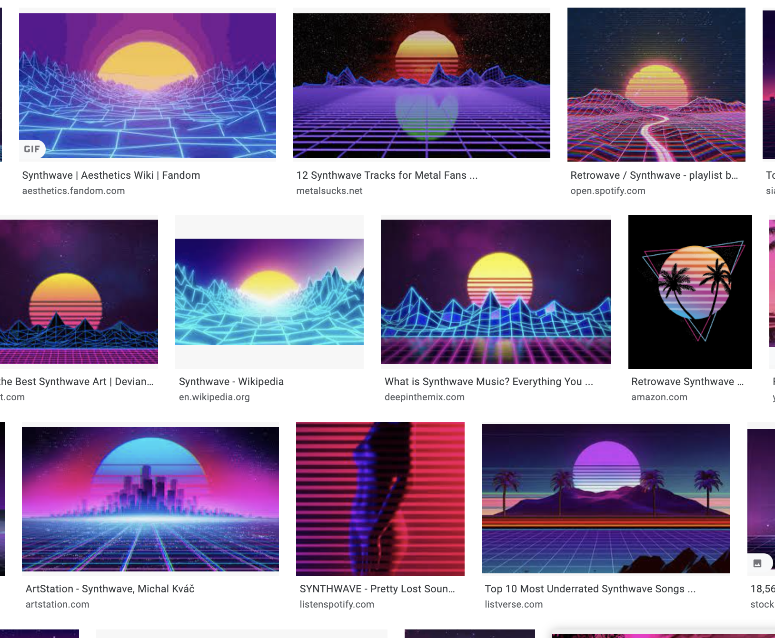

White triangular panels have been done by us and at least four other art cars shown above. Let’s get the edges right.

As of 11/4/2021: We’re awaiting the financial entity setup to order a custom triple-row strip of SK9822 from SuperLightingLED and Ray Wu. We should also get backup quotes from other Chinese contact manufacturers: We know of SOYA, Packever, iPixelLED, and SZLED at present.

As of 2/4/2022: To reduce supply chain dependencies, we’ll focus on building around 3 separate IP67 60/mSK9822 strips physically next to each other.

## Illuminated Panels

If the panels were lit, but the edges look shitty or aren’t working, it’s harder to understand the iceberg / synthwave nature of the form; that’s why we’ll prioritize edges. I think we can make the panels work too.

### Projection mapping?

One option is that someone projection maps them.

* Can it be bright enough? Ali, our in-house projection mapping expert, agreed that projection mapping is unlikely to be bright enough for exterior surfaces.
* Throw (where to mount projectors)
  + Rear projection mapping likely works on thinner films; the PC we use would probably need a matte inner surface and need a very high transmittance (and might show shadows / more framing innards). Rear projection would need to be able to hit all surfaces while avoiding the generator, refrigerated container, sound and power infrastructure, lounge, etc.
  + If font-projecting on polycarbonate, it’s probably brighter. For this, it seems the best option would be short-throw projectors hanging off the iceberg; dust, fragility, and aesthetics become open questions.
  + One potential you-can-have-it-all option: fabric panels that can be adhered (with the right removable adhesive) to the polycarbonate surface if we decide to project instead of backlight.

### Backlit Panels: Diffusion and Brightness

Human perceived brightness, like sound, operates on a power low (decreasing returns). Skipping nuance, you [quadruple output power to double perceived brightness](https://en.wikipedia.org/wiki/Gamma_correction).

We will backlighting with LED arrays. On the critical path is testing the proper diffusion distance and materials for different pixel densities. On the LAA Facebook group, there are quotes from grizzled veterans that are like, “80% of my project is just getting the diffusion right.” Hugzilla decided on [what looks like](https://www.instagram.com/p/B0o_2oaBpF6/) 3-4” separation of WS2811 bullets (40K+ inserted by hand) offset by 4”. We might We might We might do better with 30/m (or less) strips or throughole-ready strand modules like these:

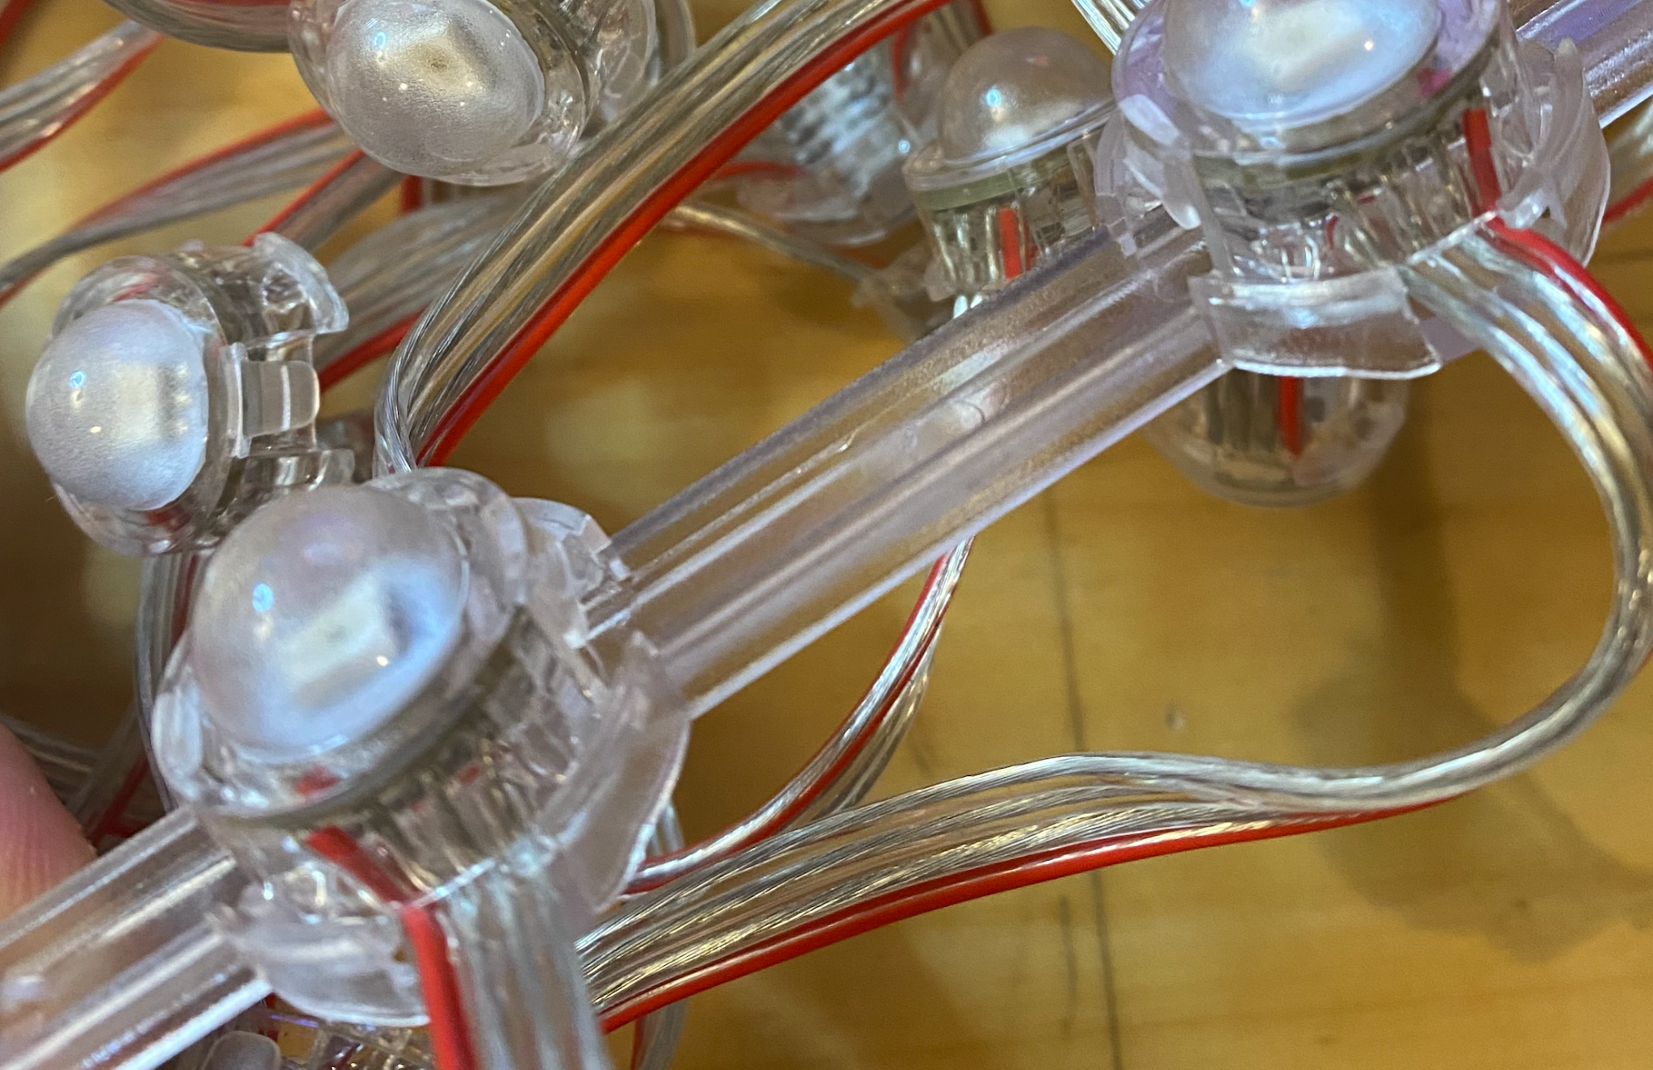

High transmission polycarbonates are more expensive and have higher lead time. See products such as [Lumen XT](https://www.modernplastics.com/wp-content/uploads/2015/05/PDS112_Lumen.pdf). If we want panels to be brighter than our first art car, our options are:

* A ton more LEDs, but still waste light in the low-transmission milky white polycarbonate
* Try frosting economical clear PC ourselves (orbital sanding)
* Compose our own composite material such as polycarbonate with a thin diffusive film bonded to it
* These more expensive LED sign polycarbonate products:

##### Polycarb light transmission

| **Polycarbonate Product** (.118” / 3mm / ⅛”) | **Light Tx rate** | **4x8’ Qty1 price** (without freight) | [**Cost multiple**](https://docs.google.com/spreadsheets/d/1RXOtxLp2K_qTG547W8WxYTBKEPxlUkB8DTHj0yOSnJA/edit#gid=556671306) **(sheet + LEDs) to double TE1’s brightness\*** | **Diffusion** | **Reel stock?** (3-8’ wide) | **Why try?** |
| --- | --- | --- | --- | --- | --- | --- |
| (For reference: Titanic’s End 1)  White #7328 (B27) (48 sheets 50x100” SO59927) Sabic Opal White Lexan | 30% | $120  @ProfPlas | 2.9 * TE1 cost | (high) | Y | <eliminated - too expensive per lumen transmitted> |
| Tuffak Lumen XT  (not as UV resistant) LC3 LC0 | 85% 90% | $369 @ProfPlas | 2.0x  2.4x | 53° 135° | N | Highest transmission  Frosted glass look  Test: Requires LEDs to be too far from panel for diffusion? |
| Tuffak DX-NR  (UV resistant)  **We chose as a group on the prototype.** | 61% | $398 @ProfPlas | 2.5x | 152° (highest) | N | What an architect would pick. Made for outdoor LED fixtures |
| Tuffak LD B48 / 2447  (UV resistant) **Keegan and Jeff would like to do this instead** | 50% | $174 (5’x10’) @ProfPlas | 2.1x | (med) | Y | Cheapest, but requires the most LEDs (soldering, power)  Only product available in reels if we want that. |
| Clear sheet; we sand | >80% | $196 |  |  | Y | <eliminated for variability> |
| Sabic (Lexan) Exell D OB | [47%](https://sfs.sabic.eu/wp-content/uploads/resource_pdf/1357857027-70672458-Lexan-Exell-D-OB-Datasheet-2012.pdf) | Not in US |  | .86 | ? | <eliminated for unavailability> |

* To [compute the cost of doubling perceived brightness](https://docs.google.com/spreadsheets/d/1Esk2DRcgMfMCqbKQhcnJz_GzM6JlNMu8LAQaKqME9Os/edit#gid=0), I use the transmission factor to find how many LEDs are required to [quadruple](https://en.wikipedia.org/wiki/Gamma_correction) the amount of transmitted light, then divide that sheet+LEDs cost by the cost of TE1’s sheet+LEDs. Quantity discounts, freight, and some costs of power to LEDs (generator, copper wire) are not included. Assumes $0.22/pixel.

#### Sample request

I’ve sent out sample chip requests to 5 vendors. Update: Received a limited pack of 5x7” from Plaskolite and Mr. Plastics. Professional Plastics has been the most responsive, so I ordered through them.

* Professional Plastics 10/14 can source all for the test, but is the most expensive. **Test order placed.** Can do CAM in San Jose.
* Mr Plastics (TE1 vendor): 10/11 - Slower so far. Requested 5x7 samples and got them quick enough. They would require us to buy a 13 pack of 4’x8’ of each product.
* Port plastics: 10/14 - Is looking for smaller samples. Went dark.
* TAP 10/14: Doesn’t carry these, will not order-in.
* Eplasics: 10/10 Only carries LW3, not LC3, will not order-in the other products.

#### LED Density

I’ve referenced TE1 Chris’ email and the old FB group: TE1 strips [were 30/m](https://www.facebook.com/photo/?fbid=10100313900452778&set=g.1434882210102871) at [8” infra-strip infra-strip infra-strip spacing](https://www.facebook.com/photo/?fbid=10100328171448588&set=g.1434882210102871). This is about 150 LEDs per square meter (~34 W/m^2 assuming 45mA WS2812b). The 55mm-spaced modules in a grid would double this to 333 LEDs per square meter. Forming [a panel from strips](https://www.aliexpress.com/item/4000611537125.html?spm=a2g0o.store_pc_allProduct.8148356.68.6bf9689dd0Bbzf) would yield 900 LEDs per square meter; the power budget might be insane.

| **Setup** | **Product** | **Density (LEDs / m^2)** | **Power per m^2** | **kW for a std 18 wheeler (141m^2)** |
| --- | --- | --- | --- | --- |
| TE1: [8” column spacing](https://www.facebook.com/photo/?fbid=10100328171448588&set=g.1434882210102871) | 30/m 5V strips | 150 | 34 W | 4.7 kW |
| [2.15” / 55mm grid](https://www.aliexpress.com/item/32993596035.html?spm=a2g0o.store_pc_allProduct.8148356.5.41de6819By7GEv) | 55mm strand | 333 | 80 W | 11.3 kW |
| [flex panel](https://www.aliexpress.com/item/4000611537125.html?spm=a2g0o.store_pc_allProduct.8148356.68.6bf9689dd0Bbzf) | 30/m strips | 900 | 216 W | 30.5 kW |

### Detailing: Physical attachment and mounting

We built a tetrahedral light box prototype in Jan/Feb at Humanmade in SF that [tested out 7 candidate diffusion systems](https://docs.google.com/spreadsheets/d/1RXOtxLp2K_qTG547W8WxYTBKEPxlUkB8DTHj0yOSnJA/edit#gid=64051392) and hardware detail techniques. Build details and results.



A final design from the structural team (Eddie, Brian, David) is coming in December. This should be considered draft:

Quantities  
- Large panels - 24  
- Small panels - 21

(TODO update this)

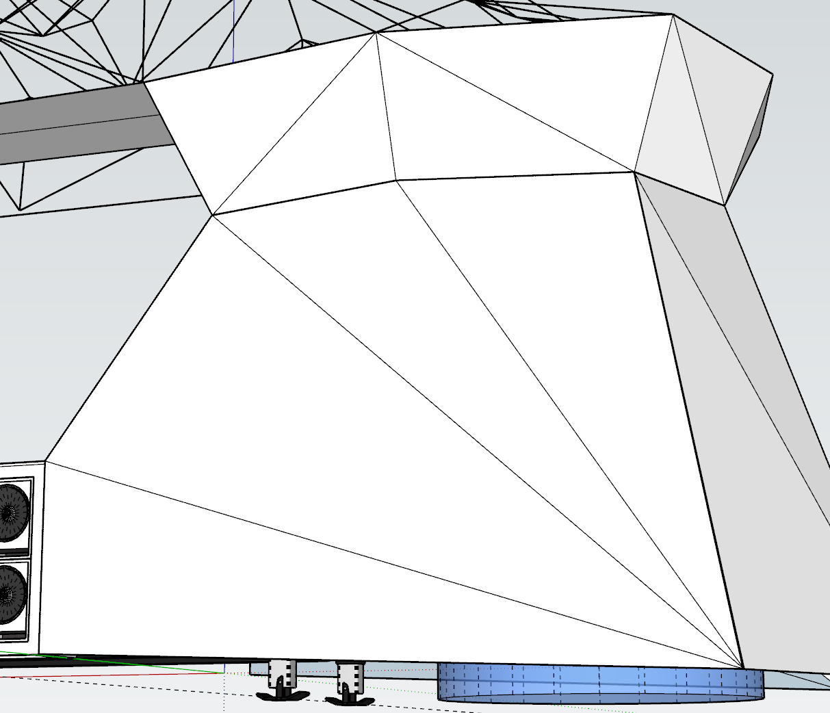

*Panel design detail concept - outdated as of January design, which is now considered final.*

Eddie spent some time considering how to create the backlit panels in a way that considers: simplicity of assembly/ correct amount of diffusion/ vibration stable/ ease of maintenance.

* Minimal or no onsite assembly.
* Complete light coverage but with minimal pixel overlap.
* Connection should be secure and minimize vibration potential.
* Dead spots from attachment and framing support should be minimized.
* Panels should be easily removed for troubleshooting.

###### 

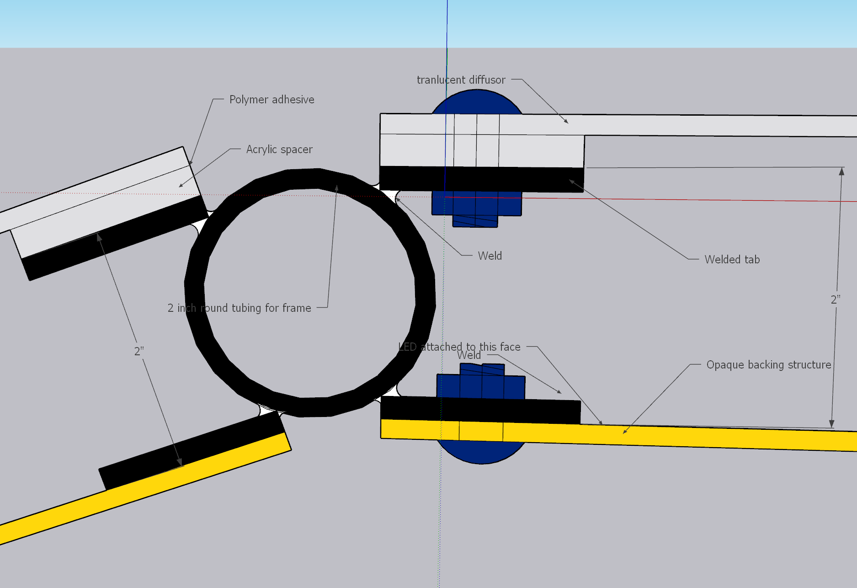

Notes:

1. Tab spacing should be 16 inches. There will be hundreds. The good news is that these tabs are great for people to learn to weld on.
2. Clamping vs welding (open decision - could go either way).
3. Edge lighting solution- It is 1” wide and could house 2 strips side by side. The bottom of the extrusion is a heatsink.  
   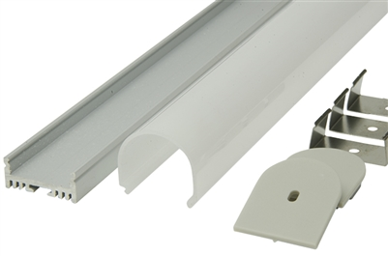  
   https://www.glowbackledstore.com/LED-Aluminum-Profile-R2-Round-Lens-p/alumr2.htm  
     
   Clamps: adjustable.

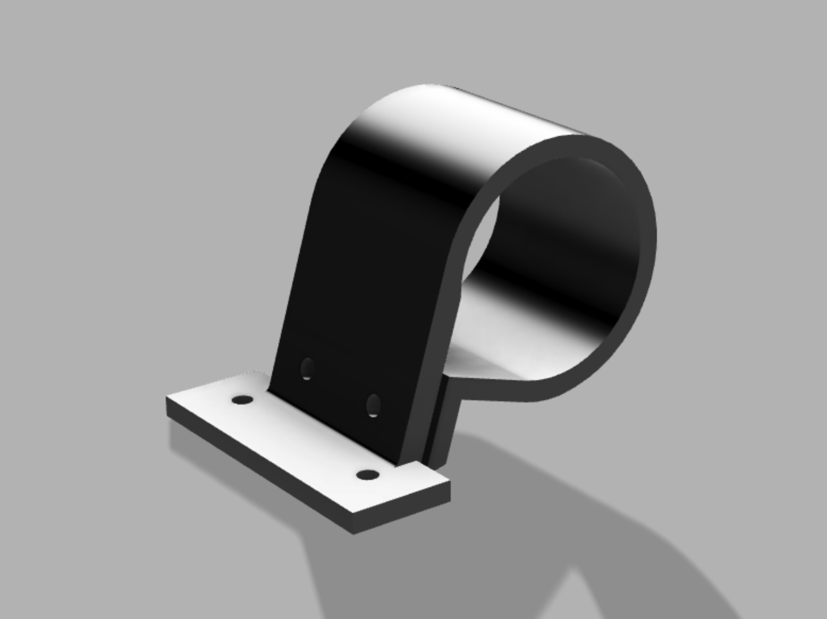

(Jeff mockup)

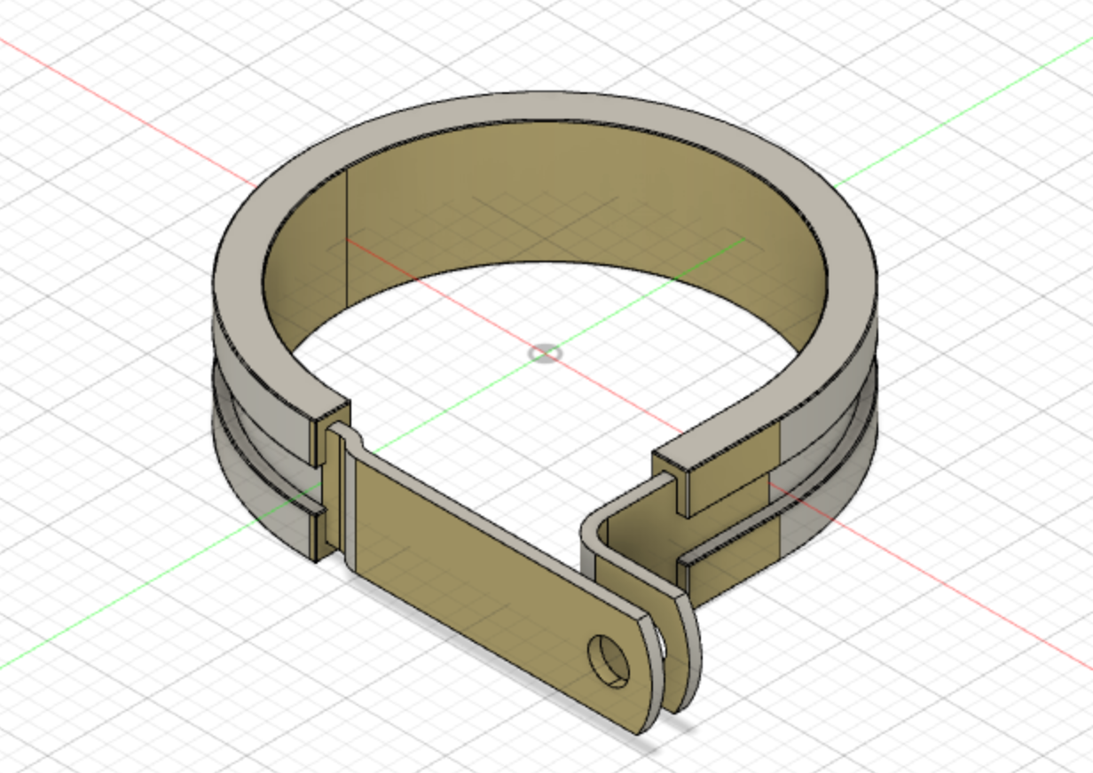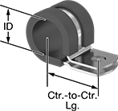

McMaster [Vibration Dampening Loop Clamps](https://www.mcmaster.com/vibration-damping-clamps/snug-fit-vibration-damping-loop-clamps/): $2.15 ea for 2” ID

Vibration may be a major issue for large sheets of plastic close to the thunderous subs.

1. Welding bonus: The tabs can come pre threaded, so a back nut would not be needed.
2. Welding can be fairly quick as the placement can be done with a large straight edge to find the plane. No measurement outside of spacing will be needed.

Obstacles seeking solution:

1. Creating a uniform backing for the edges: consistent width whether the edge is concave or convex.
2. Sizing panels super accurately becomes paramount. The panel gaps should be sized to create the perfect space for the vertex LED.
3. The front and back panel will be 2 different sizes. I need to figure out how we will find the size.
4. Sourcing large translucent panels in time.

## Sound-transparent diffusers

* Options from [this facebook post](https://www.facebook.com/groups/LEDSAREAWESOME/permalink/1030809427114516):
  + Spandex
  + Tungsten wool
  + Polypropylene Fabric

# Other Resources and Wisdom

## Art Car Founder and LED Artist Chats

In addition to the ones below, we’ve had validation discussions with Mark Slee, Anthony Rubalcaba, and Steve Pomeroy.

### Hugzilla founder chat

11/5 Spoke with Ivan, the main person behind Hugzilla

* “Don’t do it. Stop now.”
* #1 Piece of advice: You ***must*** be able to easily access and replace LEDs from the front side (outside).
* Big problems with rust on steel. “Yes, we painted, but there’s still nicks, cracks, and replacing the steel itself was utter hell”. They glued their panels to the steel - he begs us to make our panels easily removable and anticipate steel maintenance. They used an experienced independent contract manufacturer.
* Problems from amateur soldering - 4 days of troubleshooting (thankfully off-playa).
* 45,000 LEDs, he estimates they ran them at 5% intensity on average: “We used the brightest LEDs we could find, but it was just unpleasant”. Used 2” pitch (spacing). We will mitigate this with testing. We should consider fewer LEDs. He advises us to use the fewest we possibly can.
* He wishes he used fewer panels 1) to let wind through and 2) just have fewer LEDs to deal with.
* Yes, their panels sagged in the middle so they sometimes ended up welding extra members across midpoints to provide a mid panel support with spacer.
* Used acrylic, not polycarbonate, and had all the problems you would expect: Cracks from dropping, installing, wind object impact, and most of all, people fucking trying to climb the damn thing. Had to staff full time anti-climbing minders. “Next time I will just add crap for them to climb on instead.” “Please be modular - please.” He did not correctly estimate the impact of the weight of all that acrylic, steel, power, and LEDs.
* “Why did you use bullet style LEDs?” “Because we got bad advice. Do what you’re doing.” They used 4-wire (backup data line) 12V bullet strands. Used Madrix for control, but he didn’t do any of the programming. Initially they had all the power supplies centralized, but had to move them out to the panels due to voltage drop. “Use the fattest wires you can.” I think as a team we’ll be well suited to calculate and hopefully avoid mistakes like this. He seemed newer to LEDs than our team.
* First year on playa it didn’t function at all. Crazy story about the art car being lost on playa for 4 days. It’s been back one other year where it mostly worked.
* A big challenge was having to fundraise as they went, and not having a major donor and budget up front. They would have made different decisions had they known their final budget up front. Final cost (whole car): $450K.

### Christopher Schardt (Paraluna, Firmament)

Jeff and Mike have volunteered a bit with him. Selected insights:

* SOCKiTBOX, Dri-box and Harbor Freight “Bunker Hill” plastic ammo boxes
* Coat JST-SMs in liquid electrical tape
* Commonly uses the 3-LED WS2801 pucks (a less common protocol) for Firmament
* SK9822s for Paraluna (and all other POV) because of the instantaneous frame changeover, as opposed to APA102

### Emails with Hepp McCoy - Dragomi / AudioPixel

Hi Hepp!

I learned about your work on the Luminous Arts podcast, and was really blown away by the videos I've seen online of Dragomi.

In 2014, we built an [iceberg art car](https://www.kwonbae.com/works/titanicsend) (to chase ships :) with about 7K LEDs controlled by LX. It survived for 2 years before we decided to scrap it.

We're back to try again; we have a larger budget and large ambitions. I'm one of the two lighting team leads for this iteration and I've got enough constraints now to start thinking seriously about the physical design detail; We're likely looking at around 100K addressable LEDs on the new PixLite controllers.

I saw some references on L.A.A. from an Erin O'Brien and Aaron Wilson about Dragomi surviving some weather events, and I wondered if you or anyone else who helped on Dragomi would be willing to voice chat sometime about any lessons learned for physical build, durability across years, modularity, etc.

Thanks for putting this work into the world.

Jeff

—

Thanks for the good words.

I believe I remember seeing iceberg on BRC.:)

Glad to hear you have new plans in the works. Sounds like a fun project.

Yes we rebuilt Dragomi 3 times actually (and now on a 4th, but I also have a new project I'm starting)

So I have a few good knowledge of what it takes

Here are some recent photos of it before it got wrecked last year BRC that you might appreciate.

<https://drive.google.com/drive/folders/1QPWdq_C2HtvAVkm57ZiA48lSILzPtKk6?usp=sharing>

Where are you guys located? Do you have an indoor facility to work during the winter?

H

—

Hepp -

This is SUCH a clean build. I don't even get it. Where the hell is everything?

What I love about this is you make it look simple. I see the lessons learned in the evolution of the wings. The modules for panels are very clever. The design of the form seems to avoid so many problems with power and connection and serviceability. And the videos show your use of mapping is peak; form aware, not just video rendered. I don't see anyone else doing what you're doing with random/flash/particle effects/noise on those edges. Of the cars I've heard back from, this is clearly the one designed by a lighting expert.

We're planning to do metalworking and structural fab outside Nashville (they have indoor space), and lighting install in NorCal in March/April. Most of the group is in the Bay Area. Some of us might use a makerspace here for storage, CNC/laser, detail assembly.

I'm going to be open and admit I don't know the etiquette for asking people about their suppliers. On the one hand, it's like - people fly to China to vet them and spend years learning who can deliver; and if you order something custom I would understand the desire to extend that period of time where those details show up uniquely on your pieces. On the other hand, it's nice to show your suppliers your referral has sway and you can send them more work.

I think you'll have more educational scar tissue than anyone, so however you're willing to engage is appreciated. That could be questions over email, a Zoom, or whatever works for you.

Jeff

—

All this sounds awesome. Thanks for the kind words. It's always nice to hear from others who can appreciate the fine details.

>> This is SUCH a clean build. I don't even get it. Where the hell is everything?

We are storing everything underneath the flatbed, and underneath the top platform. All the wires stray within the panels, and then exit a panel at the bottom in an ideal spot to be routed under the cab and out of sight. This is the 3rd generation and we learned plenty of lessons on how to set up the cabling so we could keep things out of sight. Each panel has its own fuse box under the flatbed as well.

The other major thing in keeping things clean - is grouping all the individual triangles and shapes of a panel - into a single LED strand that gets woven through them all (and that never repeats or backtracks sections).

This forces your LED software to not just treat each strand as the same or as a strip of a video screen. It must know exactly which LED diode is in which element/shape - in order to map it all correctly.

>> We're planning to do metalworking and structural fab outside Nashville (they have indoor space), and lighting install in NorCal in March/April.

Thats great that you have that indoor space. I'd love to check it out.

I live in Boulder, CO - but I frequent SF (I lived there for 6 years), and Austin.

So who knows, maybe I could be in the area sometime.

>> I'm going to be open and admit I don't know the etiquette for asking people about their suppliers.

I've always taken a completely open and transparent approach. I've learned so much from others and the community over the years, and I always love sharing details with other tech lighting folk.

I've used Madrix and GrandMMA and LX (and I actually know the makers of all 3, and Mark Slee is a good old friend of mine as well), for certain professional gigs, but Dragomi and all my other lighting projects use 100% my own software build.

As far as hardware - I order APA102 strips (I like them better then WS chips for various reasons). (usually 5v but I use 12v more these days), from "Ray Wu on Alibaba". Or from adafruit if I'm in a pinch and can't wait for shipments from China.

The controllers for Dragomi are Falcon F16V3 boards for the LEDs (using E131), along with Philips Color Blasts (using KiNet/ArtNet), and a raspberry PI triggering the poofers (using OSC).

>> I think you'll have more educational scar tissue than anyone, so however you're willing to engage is appreciated. That could be questions over email, a Zoom, or whatever works for you.

Sure I'd love to chat and hear how I could possibly help or what problems you guys are running into.

—

Hey Hepp!

Thought I'd give you an update and ask a few questions if you have time. Thanks for sharing that you've used Ray - I've used fim for projects and generally been happy with the yield.

The plan is to have large triangular panels with strips of GS8208 arranged as rows of a 30/m triagular grid, diffused behind polycarb. The edges between panels will have 3 strips of SK9822 at 60/m. I'm pondering the pros/cons of having those custom made as a single 3-row product ([like this](https://www.superlightingled.com/triple-row-high-density-144ledsm-ws2815-addressable-led-strip-light-dc12v-high-bright-led-strip-50m164ft-per-roll-p-3235.html)). We're building a physical prototype this month with just a few panels.

Here's a recent design render from the structural team:

<img>

Here's my questions for you:

1. On Dragomi, I noticed you're using Ray-Wu style outdoor connectors. In my experience, those rings sometimes crack off, then I've had corrosion from water after about a year. I wasn't using dielectric grease on the contacts though. You must have found 4-conductor versions for APA102. Any feedback on those - would you keep using them? The only other option I'm aware of is stepping up to automotive connectors like Metri-Pack, but that's a lot of crimping. I know Christopher Schardt likes to just swab liquid electrical tape outside JST-SMs, and that's worked OK on Firmament.
2. It looks like you've centralized the Falcons and the power supplies. This fascinates me for three reasons:
   1. Heat (I'm assuming you're using something like RSP-350s with the onboard fan)
   2. Losses from the length of the power runs, especially on 5V (unless - are you using local buck converters?)
   3. Signal run - Do you remember the frequency you're driving the APA102 clock at? Or are you using differential transceivers? How long is your longest controller -> first LED signal run?
3. Related to the above, since we have so much to cover (about 300 M of the edges, and ~90 sq m of diffused panel), I was assuming I can't centralize like that, and I'd need to put 120->12V and 120->5V power supplies and controllers in more localized boxes, distributed around the car. I didn't make a big spreadsheet though to try to compute injection line resistive losses of centralizing (how much copper would be required). Another option I'm considering is doing 120->24V centrally and then 24->12 or 24->5 with local buck converters. I'm not sure if that inflates the connection work a lot. Any thoughts on these options?
4. I mentioned seeing posts about weather events and you mentioned getting wrecked at BRC and another rebuild - any lessons learned from these events? Was it weather, people, road vibration, something else?
5. Also considering the right tactile Midi/OSC controller. Thinking APC40 mk2 and Roli Lightblock.

If you're even in SF let me know. I think a couple of us are doing prototype build in Jan at the Humanmade makerspace here. No larger group build days scheduled yet - I know we're looking at east bay warehouses first.

Happy holidays, and thanks again for all the free advice.

Have you ever played with a Pixelblaze? If not, I'd love to send you a recent one (v3 on ESP32) ready to go. It's been a really fun entry into LEDs.

Jeff

—

Jeff,

Hope you had a good holiday break ~

Awesome and thanks for the update. Looks like it's coming along nicely!!

I really like the design. I assume most of the area for people will be on top of the second platform, and the bottom featured area is for dancers?

I will attempt to answer all your questions.

>> 1. On Dragomi, I noticed you're using Ray-Wu style outdoor connectors.

Yes it's true, although we were in the process of upgrading to these type of DMX [connectors](https://www.showmecables.com/by-category/connectors-adapters/audio-video/dmx-lighting) , which is what I would recommend. Wire into metal and have everything properly grounded as well.

>> 1. Christopher Schardt likes to just swab liquid electrical tape outside JST-SMs.

Chris is a great guy and had multiple chats with him throughout the years on playa.

However I would most certainly avoid every using electrical tape of any kind.

And in general we tried to use no tape on the truck at all, instead using zip ties, velcro straps, and metal wire wraps.

Rule of rule of thumb we had is "if you have to tape cables then it probably isn't hidden/stashed/wired correctly enough".

>> 2. It looks like you've centralized the Falcons and the power supplies

Yes it's because we were using outdoor cases to house the Falcons, power supplies, and fuse boxes.

Fuse boxes are important, but easy to overlook. The falcons have fuses on them, however all the other additional power connections needed their own fuse to make sure no fires would start or major damage when something would go wrong (which happens constantly on playa/at festivals/on the road).

>> 2.1. Heat (I'm assuming you're using something like RSP-350s with the onboard fan)

The fan that is included on MeanWell power supplies. We always had lots of backups (power supplies are the things that need to be replaced the most), and the MeanWell units definately were better than any other brand.

I was always worried about heating. But the most important thing is: don't run the lights during the day.

For a few festivals where we were running during the day (in a shaded area), I would always make sure the outdoor cases housed all the power supplies were not sealed shut.

For all the replacements we had to have (like 2 a year I would say), I don't think it had to do with overheating, but I could be wrong.

If so, it's almost a welcome tradeoff to have cases that really kept 98% of playa and dirt out.

>> 2.2 Yes I have learned to move to 12v and not 5v. I still have plenty of 5v and will continue to buy it.

Really, there is no good math on figuring out the power loss.

Yes it's ohms law. I had a few electrical guys tell me what we would do and I always found we could cut that in half and be fine.

We generally would make sure all the cable runs were under 50'.

The biggest issue we had was not with power but data.

If you run your data line over about 20' it should be in a twisted grounded cable.

It was a mystery for a while why some things would be flashing randomly.

We ended up just using cut up cat5 cables for the long runs and all the problems when away.

>> 2.3. Signal run - I just use controllers that obfuscate most details for me, and provide a FPS (framerate / hertz), which I'm not sure you are referring to or not.

As far as FPS - I like going for 60-120 if possible (falcons go 60 I believe), but have had to sacrifice to 30 for some (pixel pushers, RIP), which is the lowest I would ever want to go.

I've had people tell us they could find Dragomi across the playa because our "LEDs flashed different", and some nerds would say they appreciated our framerate compared to most displays.

It was really something people would notice that would make us stand out.

I think it's not only the controllers, but also most importantly most people's software / and even commercial applications - send out terrible FPS rates.

Also people think they can use their phone or a laptop with multiple other processes that might be running or pop in and out, and those would cause slow downs.

Some of my favorite LED art I would walk up to and sadly see it intermittently "chug".

It might take a trained eye to notice, but it affects everyone at least subconsciously.

The only way to properly create smooth and soothing LED animation is to have fast framerates.

Thankfully it's getting much better these days I think with faster processing power on devices/machines.

I would recommend you have a dedicated machine that is beefy and just out of sight protected somewhere.

Then you would wire midi controllers (we've tried so many things, but long USB midi controllers with extensions work best), or any other device to connect to your software.

>> 3. Regarding power runs, I'd have to do the math. Do you have a wiring diagram in the works?

>> 4. Oh man. I have seen everything you could imagine, and that's not really an understatement. Before Dragomi I ran another artcar for 5 years, and it was even crazier back then.

We've had all sorts of accidents. But actually nearly all the damage has come from not properly storing the art car for the winter. We thought we did a ok job but the tarps were never enough for the CO wind and snow.

We learned to store indoors.

But yes, weather by far will be your #1 obstacle in causing you to maintain a well functioning ship. Not only for all your gear and electronics, but for participants, unprepared spectators, and your trusty staff/crew who will be tasked with constantly "reading the seas" and "batching the hatches" when needed.

My best recommendation here would be to over-engineer all art car structures as a whole, areas where people can retreat, and improve the housing equipment/strategies for all gear/electronics, which will be your holy savior in winning this battle.

>> Also considering the right tactile Midi/OSC controller. Thinking APC40 mk2 and Roli Lightblock.

APC40 mk2 is my godsend (it's the only affordable controller you can control it's onboard lights, with just a Midi in connection - otherwise it just adds another protocol to control), for all the shows and other events I do.

It's been the medium in which I've been able to surface the functionality of my software to the users/LDs (including moving heads, projectors, ect in the same 3d pixelmapped universe), and so I'm forever in love the controller.

I actually wrote a java api for it [here](https://github.com/hepp/akai-apc40-mk2) ( I have a vastly improved version I need to update to github, if you are interested let me know)

However - I certainly would not consider APC40 mk2 playa worthy. It is barely club worthy.

I have been using Akai products for a long time, but unfortunately the quality has come down dramatically.

I actually go for the older models, particularly the Akai LPD8.

The main issue is knobs and sliders stop working. Controllers with knobs and not sliders are more reliable.

I have put the LPD8 through hell and back, and they still hold up.

Also they are cheap so you can buy 5 of them instead of relying on 1-2 controllers.

I've seen people build elaborate custom metal midi controllers, but nearly always something goes wrong and they don't have a backup.

I have backups of everything, and multiple backups for anything controller and essential gear wise.

And at the end of the day it will give you peace of mind about everything, for when you are not on the truck you don't have to worry about your fancy controller cause you only have one, etc.

When a party is going on I don't even want to think about it and fix anything, just grab the backup and look at the suspect one later.

Also regarding controllers - I would recommend avoiding the trap to ever use a screen of any kind.

Not only are they unreliable to use devices or touch screens, but you have to keep your eyes on the screen and not on the lights, where they should be.

More simple controllers come more easily for people to not have to stare at while using.

I have not used the Roli Lightblock.

Looks cool, however I would avoid unnecessarily electronics on a controller unless it really makes it a better experience.

If you really want to do it I would suggest getting one and really testing it out, and potentially subjecting one to extreme conditions.

Also similar to a screen you might not want to look at a controller, and ones with a grid of buttons tend to be the least intuitive / tactical to control while looking elsewhere.

>> Have you ever played with a Pixelblaze? If not, I'd love to send you a recent one (v3 on ESP32) ready to go. It's been a really fun entry into LEDs.

I have not yet. I'm a bit behind on the latest tech however. Looks cool.

Sure if you have a extra one and it's not a burden currently, you can send one to: Hepp Maccoy, PO BOX 697, Boulder, CO 80306

>> If you're even in SF let me know.

That is so great you are out there. I'm not sure when I will be out there, perhaps this June and I can plan on it, assuming the world all gets better :)

>> Thanks again for all the free advice.

Glad to help a fellow aspiring artist out! I know how much work it takes!

I'm excited to see it come together!

I hope this helps, I wrote it kind of quickly, so let me know if you have questions or if there is anything else I can elaborate on.

Cheers,

H

## Other LED Knowledge and Resources

* [Diffusion material commentary](https://www.facebook.com/groups/LEDSAREAWESOME/posts/965097213685738/) (fb)
* [Addressable LED mega-sheet](https://docs.google.com/spreadsheets/d/10pHG7_VIVltyqJK1Y0T5g3Iq6YJV2MnhMp3UcAVB-GA/edit#gid=961824890)
* Mike Harrison [Everything I’ve Learnt About LEDs](https://www.youtube.com/watch?v=5SQt1f4PsRU)
* Manufacturers
  + Ray Wu / Shenzen-Rita
  + [Shiji](https://www.shiji-led.com/) (Irijule, MyPixelLights founders recommended)
  + CN Tour notes from Louis Baeudoin:
    - [SZLED Color](http://www.szledcolor.com/)
    - [SOYA](http://www.soyaled.com/)
    - [iPixel LED](https://www.ipixelleds.com/)
  + [Gree-LEDs](https://www.gree-leds.com/white&wwa-digital-strip/): Likely source for Adafruit CWW APA102; Has uncommon densities (e.f. 48/m)
  + [Packever](http://www.packever.com/) (Chrisopher Schardt’s favorite supplier). However:  
    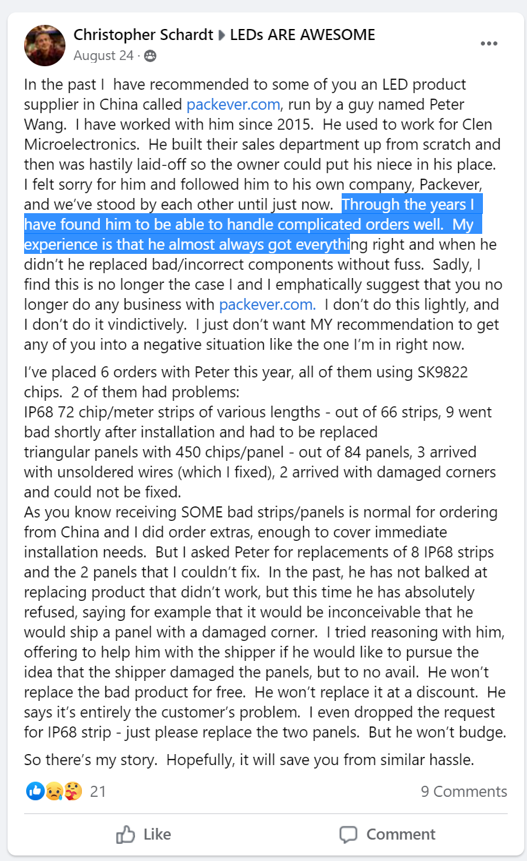

2023 Wire harness socket plug connector connections pinout documentation:

<https://docs.google.com/document/d/1-ArvYFGNBg4ephtT7BvEZfQvMDzQcDvBMCvjGnq64g0/edit>